# DP-200

# Question1 Implement non-relational data stores – D -

## Question1.1

You are a data engineer for your company. Your company wants to build an e-commerce site that allows vendors to sell their products online. Each vendor's product can have an arbitrary number of attributes. For example, Vendor A has a product named Bicycle Z that contains attributes Price, Description, Brand, PartNumber, and Size. Vendor B has the same product named Bicycle Z that contains attributes Price, Description, Weight, and Model. You want to implement a solution that does not restrict the product attributes that are used by each vendor. Your solution must allow you to use .NET to query product data.

You need to create the appropriate data store.  
  
Solution: You create a Cosmos DB account that uses the Table API.  
  
Does this solution meet the goal?

No

Yes

## Question1.2

You are a data engineer for your company. Your company wants to build an e-commerce site that allows vendors to sell their products online. Each vendor's product can have an arbitrary number of attributes. For example, Vendor A has a product named Bicycle Z that contains attributes Price, Description, Brand, PartNumber, and Size. Vendor B has the same product named Bicycle Z that contains attributes Price, Description, Weight, and Model. You want to implement a solution that does not restrict the product attributes that are used by each vendor. Your solution must allow you to use .NET to query product data.  
  
You need to create the appropriate data store.  
  
Solution: You create an Azure SQL Database account that uses a managed instance.  
  
Does this solution meet the goal?

No

Yes

## Question1.3

You are a data engineer for your company. Your company wants to build an e-commerce site that allows vendors to sell their products online. Each vendor's product can have an arbitrary number of attributes. For example, Vendor A has a product named Bicycle Z that contains attributes Price, Description, Brand, PartNumber, and Size. Vendor B has the same product named Bicycle Z that contains attributes Price, Description, Weight, and Model. You want to implement a solution that does not restrict the product attributes that are used by each vendor. Your solution must allow you to use .NET to query product data.  
  
You need to create the appropriate data store.  
  
Solution: You create a table storage account.  
  
Does this solution meet the goal?

No

Yes

## Question1.4

You are a data engineer for your company. Your company wants to build an e-commerce site that allows vendors to sell their products online. Each vendor's product can have an arbitrary number of attributes. For example, Vendor A has a product named Bicycle Z that contains attributes Price, Description, Brand, PartNumber, and Size. Vendor B has the same product named Bicycle Z that contains attributes Price, Description, Weight, and Model. You want to implement a solution that does not restrict the product attributes that are used by each vendor. Your solution must allow you to use .NET to query product data.  
  
You need to create the appropriate data store.  
  
Solution: You create a Cosmos DB account that uses the SQL API.  
  
Does this solution meet the goal?

No

Yes

# Question5 Implement non-relational data stores

Case Study

Complete the Case Study

* Overview

Company1 is a food delivery company with a global presence. Company1 data solutions use the following Azure data products:

* Azure Blob Storage to store order tracking status
* Azure Cosmos DB to store orders, restaurant (menu, address, contact info) and customer data
* Azure SQL Database elastic pool used by the company’s internal systems

You need to support plans to release this software in a new Azure region.

* Requirements
* The platform must be resilient in case of an outage impacting one Azure availability zone.
* You need to provide a mobile application secure access to the orders database that is hosted in Azure Cosmos DB.
* The mobile application needs to perform read and write queries directly to the orders database.
* The internal systems use 15 separate databases configured in an elastic pool.
* The internal system databases must be readable in case of availability zone outage.
* In this new region deployment, you need to provide an external partner of Company1 direct read access to the tracking order history that is stored in blob storage.
* Access to Company1 by the external partner should be limited and should automatically expire after two months.
* Orders Database

During the first marketing campaign of the previous regional launch, the database was the cause of a bottleneck while reading the orders collection. The Request Units (RU) database throughput needed to be increased in other to eliminate the bottleneck. Collections different from orders throughput did not change during the marketing campaign.

* Internal  
  system databases

You need to implement a daily administrative task on all databases. This administrative task is a script written in PowerShell.

## Question 5.1

You need to implement replication so that the internal system databases meet the requirements.   
  
Which two actions should you perform? Each correct answer presents part of the solution.

1. Configure SQL Data Sync for each database.
2. Create an Azure SQL Server elastic pool in another region.
3. Enable geo-replication for each database.
4. Create a Sync Group in elastic pool.

## Question 5.2-

you need to implement the redundancy strategy for order tracking status storage to meet the requirements. Costs need to be kept to a minimum.   
  
Which data redundancy strategy and storage account type should you use? To answer, select the appropriate options from the drop-down menus.

You have been given the task to implement the redundancy strategy for order tracking status storage to meet the appropriate requirements. The costs should have to be kept as minimum as possible.

What data redundancy strategy and storage account type should you be using? Select the relevant options to answer the question.

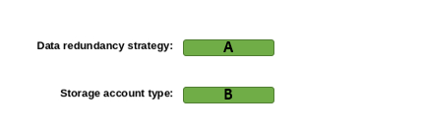

A)

1. Geo Redundant Storage (GRS)
2. Local Redundant Storage (LRS)
3. Zone Redundant Storage (ZRS)

B)

1. Block blob storage accounts
2. General-purpose v2

## Question 5.3-

You need to implement daily administrative tasks for the internal system databases. You need to minimize administrative efforts.   
  
Which solution should you use?

1. SQL Server Agent
2. Azure Alerts action group
3. Elastic Database Jobs
4. Azure Data Factory

## Question 5.4-

You need to create the necessary credentials for the mobile client application to connect with Azure Cosmos DB.   
  
Which credential key and permission should you use to to meet security requirements? To answer, select the appropriate options from the drop-down menus.

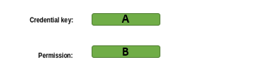

A)

1. Azure Active Directory (Azure AD) user
2. Master Key
3. Resource Toke

B)

1. All
2. Cosmos DB Operator role
3. Read

## Question 5.5-

You need to grant the external partner of Company1 access to the blob containers that store the order tracking status.    
  
Which authorization method should you use to meet security requirements?

Anonymous public read access

Shared Key authorization

Shared access signatures (SAS)

Azure Active Directory (Azure AD) role-based access control (RBAC)

# Question10 Manage data security

Case Study

**Instructions**  
  
This case study contains a series of questions that present the same scenario. Each question in the series contains a unique solution that might meet the stated goals. Some question sets might have more than one correct solution, while others might not have a correct solution.  
  
Note: You cannot go back or review questions of this type on the actual certification exam.

## Question 10.1-

You manage an Azure SQL Database containing a column with sensitive data. The column is used for joins by an application.  
  
You need to configure encryption for this database to protect the column.  
  
Solution: You configure Always Encrypted with a randomized type.  
  
Does the solution meet the goal?

No

Yes

## Question 10.2-

You manage an Azure SQL database containing a column with sensitive data. The column is used for joins by an application.  
  
You need to configure encryption for this database to protect the column.  
  
Solution: You configure Always Encrypted with a deterministic type.  
  
Does the solution meet the goal?

No

Yes

## Question 10.3-

You manage an Azure SQL database containing a column with sensitive data. The column is used for joins by an application.  
  
You need to configure encryption for this database to protect the column.  
  
Solution: You configure dynamic data masking (DDM) with random masking.   
  
Does the solution meet the goal?

No

Yes

## Question 10.4-

You manage an Azure SQL database containing a column with sensitive data. The column is used for joins by an application.  
  
You need to configure encryption for this database to protect the column.  
  
Solution: You configure dynamic data masking (DDM) with partial masking.  
  
Does the solution meet the goal?

No

Yes

# Question14 - Develop batch processing solutions

Case Study

**Instructions**  
  
This case study contains a series of questions that present the same scenario. Each question in the series contains a unique solution that might meet the stated goals. Some question sets might have more than one correct solution, while others might not have a correct solution.  
  
Note: You cannot go back or review questions of this type on the actual certification exam.

## Question 14.1-

You keep Azure Storage access keys in Azure Key Vault.  
  
You need to configure a reference to those keys from within Azure Databricks to enable secure access to Azure Blob Storage.  
  
Solution: You create a secret scope using the Databricks CLI (version 0.7.1 and above).  
  
Does this solution meet the goal?

Yes

No

## Question 14.2-

You keep Azure Storage access keys in Azure Key Vault.  
  
You need to configure a reference to those keys from within Azure Databricks to enable secure access to Azure Blob Storage.  
  
Solution: You create a secret scope using the Secrets API via the Azure Databricks 2.0/secrets/scopes/create endpoint.  
  
Does this solution meet the goal?

Yes

No

## Question 14.3-

You keep Azure Storage access keys in Azure Key Vault.  
  
You need to configure a reference to those keys from within Azure Databricks to enable secure access to Azure Blob Storage.  
  
Solution: You open Azure Databricks workspace from Azure portal, add #secrets/createScope to its URL, and fill in all the details to create the secret scope.  
  
Does this solution meet the goal?

Yes

No

# Question17 Develop batch processing solutions

Case Study

**Instructions**  
  
This case study contains a series of questions that present the same scenario. Each question in the series contains a unique solution that might meet the stated goals. Some question sets might have more than one correct solution, while others might not have a correct solution.  
  
Note: You cannot go back or review questions of this type on the actual certification exam.

## Question 17.1-

You are a data engineer. You are developing a data ingestion solution that ingests data from large pipe-delimited text files in an Azure Data Lake Gen 1 storage account to Azure Data Warehouse.  
  
You need to load the data.  
  
Solution:  
  
You do the following:

* Create an external file format and external data source.
* Create an external table that uses the external data source.
* Load the data from the external table.

Does this solution meet the goal?

Yes

No

## Question 17.2-

You are a data engineer. You are developing a data ingestion solution that ingests data from large pipe-delimited text files in an Azure Data Lake Gen 1 storage account to Azure Data Warehouse.  
  
You need to load the data.  
  
Solution:  
  
You do the following:

* Create an Azure Databricks account and a linked server.
* Create an external table that points to the Azure Databricks account.
* Load the data by running the dbutils.fs.cp command.

Does this solution meet the goal?

Yes

No

## Question 17.3-

You are a data engineer. You are developing a data ingestion solution that ingests data from large pipe-delimited text files in an Azure Data Lake Gen 1 storage account to Azure Data Warehouse.  
  
You need to load the data.  
  
Solution:  
  
You do the following:

* Create an Azure Cosmos DB account and a linked server.
* Create an external table that points to the Azure Cosmos DB account.
* Load the data by running the BULK IMPORT statement.

Does this solution meet the goal?

Yes

No

# Question20 Develop streaming solutions - D

Case Study

**Instructions**  
  
This case study contains a series of questions that present the same scenario. Each question in the series contains a unique solution that might meet the stated goals. Some question sets might have more than one correct solution, while others might not have a correct solution.  
  
Note: You cannot go back or review questions of this type on the actual certification exam.

## Question 20.1-

You are using Azure Stream Analytics (ASA) to process real-time defect detection events from your factory’s production lines.  
  
You need to select the right windowing function in your ASA job’s SELECT query, so that you can:

* Group events per line if they occur within specific time intervals between each other, but not exceeding maximum duration time set for the window.
* Filter out periods of time when no defects are reported.
* Count each event only once.

Solution: In the ASA job query, you group events by using the session window.   
  
Does this solution meet the goal?

No

Yes

## Question 20.2-

You are using Azure Stream Analytics (ASA) to process real-time defect detection events from your factory’s production lines.  
  
You need to select the right windowing function in your ASA job’s SELECT query, so that you can:

* Group events per line if they occur within specific time intervals between each other, but not exceeding maximum duration time set for the window.
* Filter out periods of time when no defects are reported.
* Count each event only once.

Solution: In the ASA job query, you group events by using the tumbling window.  
  
Does this solution meet the goal?

No

Yes

## Question 20.3-

You are using Azure Stream Analytics (ASA) to process real-time defect detection events from your factory’s production lines.  
  
You need to select the right windowing function in your ASA job’s SELECT query, so that you can:

* Group events per line if they occur within specific time intervals between each other, but not exceeding maximum duration time set for the window.
* Filter out periods of time when no defects are reported.
* Count each event only once.

Solution: In the ASA job query, you group events by using the hopping window.   
  
Does this solution meet the goal?

No

Yes

## Question 20.4-

You are using Azure Stream Analytics (ASA) to process real-time defect detection events from your factory’s production lines.  
  
You need to select the right windowing function in your ASA job’s SELECT query, so that you can:

* Group events per line if they occur within specific time intervals between each other, but not exceeding maximum duration time set for the window.
* Filter out periods of time when no defects are reported.
* Count each event only once.

Solution: In the ASA job query, you group events by using the sliding window.   
  
Does this solution meet the goal?

Yes

No

# Question24 Develop streaming solutions

Case Study

**Instructions**  
  
This case study contains a series of questions that present the same scenario. Each question in the series contains a unique solution that might meet the stated goals. Some question sets might have more than one correct solution, while others might not have a correct solution.  
  
Note: You cannot go back or review questions of this type on the actual certification exam.

## Question 24.1-

You are a data engineer for an autonomous vehicle manufacturer. Each vehicle contains a transmitter that submits sensor data over Advanced Message Queuing Protocol (AMQP). You want to retrieve the sensor data in real time so that you can extract relevant information, transform it, and then send it to Power BI.  
  
You need to implement the solution.  
  
Solution:  
  
You do the following:

* Create an Event Hub instance.
* Create a Stream Analytics job that uses a query to extract data.

Does this solution meet the goal?

Yes

No

Question 24.2-

You are a data engineer for an autonomous vehicle manufacturer. Each vehicle contains a transmitter that submits sensor data over Advanced Message Queuing Protocol (AMQP). You want to retrieve the sensor data in real time so that you can extract relevant information, transform it, and then send it to Power BI.  
  
You need to implement the solution.  
  
Solution:  
  
You do the following:

* Create an IoT Hub instance.
* Create a Stream Analytics job that uses a query to extract data.

Does this solution meet the goal?

Yes

No

## Question 24.3-

You are a data engineer for an autonomous vehicle manufacturer. Each vehicle contains a transmitter that submits sensor data over Advanced Message Queuing Protocol (AMQP). You want to retrieve the sensor data in real time so that you can extract relevant information, transform it, and then send it to Power BI.  
  
You need to implement the solution.  
  
Solution:  
  
You do the following:

* Create an Azure Databricks instance.
* Create an Azure Automation runbook that extracts and queries data from Databricks.

Does this solution meet the goal?

No

Yes

## Question 24.4-

You are a data engineer for an autonomous vehicle manufacturer. Each vehicle contains a transmitter that submits sensor data over Advanced Message Queuing Protocol (AMQP). You want to retrieve the sensor data in real time so that you can extract relevant information, transform it, and then send it to Power BI.  
  
You need to implement the solution.  
  
Solution:  
  
You do the following:

* Create an Azure Relay service.
* Create an Azure Function app that extracts and queries data from Azure Relay.

Does this solution meet the goal?

. Question 4

Yes

No

# Question28 Develop streaming solutions

Case Study

Complete the Case Study

* Overview

Company A delivers exams to test centers around the world. Each test center uses a web application that displays exam content. Exam content is retrieved from a web API hosted as an Azure App Service.

* Problem

It appears that some test centers are passing substantially more candidates than others. An investigation is underway to determine whether or not some test centers are allowing candidates to cheat on exams. It appears that the suspected cheating also occurs around the same time of day. You must be able to determine the number of pass results that occur at a test center within 20 minutes of each other.

* Solution

The IT Director wants you to implement a solution that sends exam data to Azure as soon as the candidate completes the exam. Data includes the candidate's name, ID, test center number, exam number, score, date, time, and length of exam. You must have this data sent to Power BI so that the business investigator can determine whether or not a physical investigation at the test centers in question should be made. Because you are proficient in SQL, you want to use a solution that allows you to take advantage of your SQL skills. You also want to provide test data for analysis before the real data is received.

* Question 1
* Question 2
* Question 3
* Question 4
* Question 5

## Question 28.1-

You need to have the test center web application send exam data to Azure.  
  
Which technology should you choose to receive the data?

Azure Relay

Azure Databricks

Event Grid

Event Hub

## Question 28.2-

You need to choose the technology to query the data, filter it, and send it to Power BI.  
  
Which technology should you choose?

WebJob

HDInsight

Function app

Stream Analytics

## Question 28.3-

You need to choose the windowing function that is most appropriate.  
  
Which windowing function should you use?

Sliding

Hopping

Tumbling

Session

## Question 28.4-

You need to add test data for analysis in Azure.  
  
Which two data formats should you use? Each correct answer presents a complete solution.

1. YAML
2. JSON
3. CSV
4. XML

## Question 28.5-

You are specifying the input data source for the solution that queries the data, filters it, and sends it to Power BI.  
  
What should you do?  
  
For each of the following statements, select Yes if the statement is true. Otherwise, select No.

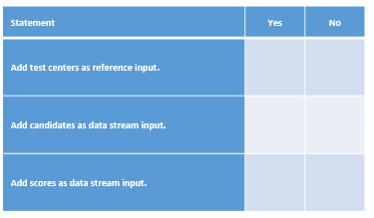

# Question33 Develop streaming solutions

Case Study

Complete the Case Study

* Solution Evaluation
* Question 1
* Question 2
* Question 3
* Question 4

**Instructions**  
  
This case study contains a series of questions that present the same scenario. Each question in the series contains a unique solution that might meet the stated goals. Some question sets might have more than one correct solution, while others might not have a correct solution.  
  
Note: You cannot go back or review questions of this type on the actual certification exam.

## Question 33.1-

You use Azure Stream Analytics to stream real-time IoT sensor data for a brewery company.  
  
You need to use a window function with a fixed-size. Events should belong to a single window.  
  
Solution: You analyze the stream with a session window function.

Does the solution meet the goal?

No

Yes

## Question 33.2-

You use Azure Stream Analytics to stream real-time IoT sensor data for a brewery company.  
  
You need to use a window function with a fixed-size. Events could belong to more than one window.  
  
Solution: You analyze the stream with a tumbling window function.  
  
Does the solution meet the goal?

No

Yes

## Question 33.3-

You use Azure Stream Analytics to stream real-time IoT sensor data for a brewery company.  
  
You need to use a window function with a fixed-size. Events could belong to more than one window.  
  
Solution: You analyze the stream with a hopping window function.  
  
Does the solution meet the goal?

Yes

No

## Question 33.4-

You use Azure Stream Analytics to stream real-time IoT sensor data for a brewery company.  
  
You need to use a window function with a fixed-size. Events could belong to more than one window.  
  
Solution: You analyze the stream with a sliding window function.  
  
Does the solution meet the goal?

No

Yes

# Question37 Monitor data storage

Case Study

Complete the Case Study

* Background

You are building a modern data warehouse solution for your company.  
  
Consumer and sales data is currently stored in an Azure SQL Database, while the product catalog is maintained in a Cosmos DB backend. The Marketing department also has access to the market research data, published weekly by a third-party vendor on their Amazon S3 storage in CSV format.  
  
The Marketing team wants to use PowerBI as a reporting tool and query against a single consolidated dataset in Azure SQL Data Warehouse. You have internal data scientists who can help with the data transformation and consolidation.  
  
Your company is using Cherwell as its service desk platform. You establish a bi-directional connection between your Azure subscription and Cherwell using a connector from the Azure Marketplace, but you have not used it yet.

* Business requirements

The new data warehouse solution must meet the following business requirements:

* Unauthorized users should not be able to see the contact details of consumers in Azure SQL Data Warehouse.
* System owners want to enforce the data retention policy and every month delete consumers who were not active for more than two years.
* Technical requirements

The new data warehouse solution must meet the following technical requirements:

* Market research data must be copied over to Azure and retained in its original format, storing files in a year and month-based hierarchical structure.
* Incidents with Azure SQL Data Warehouse based on Azure Monitor alerts need to be logged automatically in Cherwell using an existing Azure connection.
* Question 1
* Question 2
* Question 3
* Question 4
* Question 5

## Question 37.1-

You need to select an Azure resource to store market research raw data.  
  
Which resource should you choose?

1. Azure Managed Disks
2. Azure Table Storage
3. Azure Data Lake Storage Gen2
4. Azure Cosmos DB

## Question 37.2-

You need to enable the required protection of consumer contact details in Azure SQL Data Warehouse.  
  
What should you do?

1. Enable Transparent Data Encryption (TDE).
2. Enable row level security (RLS).
3. Enable Dynamic Data Masking (DDM).
4. Create a secret in Azure Key Vault.

## Question 37.3-

You create partitions in SQL Data Warehouse to support the monthly deletion of obsolete users.  
  
After uploading the historical data, your team realizes that the date partition needs to be further split. You use a SQL query to perform the task but get an error message for the ALTER PARTITION statement, as shown in the exhibit.  
  
You need to resolve the problem without emptying the target partition.  
  
Which three actions should you perform in sequence? To answer, move the appropriate actions from the list of possible actions to the answer area and arrange them in the correct order.

Possible actions

Actions in order

* Use the ALTER TABLE statement with the SWITCH clause.
* Drop the table.
* Disable the columnstore index.
* Use the ALTER TABLE statement with the SPLIT clause.
* Rebuild the columnstore index.

## Question 37.4-

Your data scientists report that their queries in Azure SQL Data Warehouse often stay in Suspended mode around lunch time.  
  
You need to monitor the execution of the queries using Dynamic Management Views (DMVs) to identify the longest running ones.  
  
Which DMV should you use?

1. sys.dm_pdw_exec_requests
2. sys.dm_exec_sessions
3. sys.dm_pdw_exec_sessions
4. sys.dm_exec_requests

## Question 37.5-

You are configuring a new rule in Azure Monitor to trigger an alert if the number of the failed connections exceeds 30 within a 10-minute interval.  
  
You need to choose the right action type to log incidents in Cherwell when an alert is fired. You need to configure it with the Portal UI and use the existing connection to the service desk platform.  
  
Which action type should you choose?

1. Automation Runbook
2. Azure Functions
3. IT Service Management Connector (ITSMC)
4. Push Notification

# Question42 Monitor data storage

Case Study

Complete the Case Study

* Solution Evaluation
* Question 1
* Question 2
* Question 3

**Instructions**  
  
This case study contains a series of questions that present the same scenario. Each question in the series contains a unique solution that might meet the stated goals. Some question sets might have more than one correct solution, while others might not have a correct solution.  
  
Note: You cannot go back or review questions of this type on the actual certification exam.

## Question 42.1-

You are a data engineer for your company. You manage an Azure SQL Database service. You want to monitor the database weekly for performance.  
  
You need to choose a tool or service that monitors the database for performance opportunities through the creation or dropping of indexes.  
  
Solution: You use Query Performance Insight.  
  
Does this solution meet the goal?

No

Yes

## Question 42.2-

You are a data engineer for your company. You manage an Azure SQL Database service. You want to monitor the database weekly for performance.  
  
You need to choose a tool or service that monitors the database for performance opportunities through the creation or dropping of indexes.  
  
Solution: You use SQL Database Advisor.  
  
Does this solution meet the goal?

No

Yes

## Question 42.3-

You are a data engineer for your company. You manage an Azure SQL Database service. You want to monitor the database weekly for performance.  
  
You need to choose a tool or service that monitors the database for performance opportunities through the creation or dropping of indexes.  
  
Solution: You use Azure Advisor.  
  
Does this solution meet the goal?

No

Yes

Case Study

Complete the Case Study

* Solution Evaluation
* Question 1
* Question 2
* Question 3

**Instructions**  
  
This case study contains a series of questions that present the same scenario. Each question in the series contains a unique solution that might meet the stated goals. Some question sets might have more than one correct solution, while others might not have a correct solution.  
  
Note: You cannot go back or review questions of this type on the actual certification exam.

## Question 45.1-

You have an Azure Synapse Analytics SQL pool (data warehouse). Some tables contain sensitive data.  
  
The applicable tables/columns must be discovered and categorized. Access to the sensitive data must be logged and reported.  
  
You need to configure the solution to meet the requirements.  
  
Solution: Perform the following actions:

* Create a Log Analytics workspace.
* Enable database auditing.
* Enable Advanced Data Security.
* Classify the sensitive data.
* Use the built-in Access to Sensitive Data portal dashboard.

Does this solution meet the goal?

No

Yes

## Question 45.2-

You have an Azure Synapse Analytics SQL pool (data warehouse). Some tables contain sensitive data.  
  
The applicable tables/columns must be discovered and categorized. Access to the sensitive data must be logged and reported.  
  
You need to configure the solution to meet the requirements.  
  
Solution: Use the Set-AzSqlServerAuditPowerShell cmdlet.  
  
Does this solution meet the goal?

No

Yes

## Question 45.3-

You have an Azure Synapse Analytics SQL pool (data warehouse). Some tables contain sensitive data.  
  
The applicable tables/columns must be discovered and categorized. Access to the sensitive data must be logged and reported.  
  
You need to configure the solution to meet the requirements.  
  
Solution: Perform the following actions:

* Enable database auditing.
* Create security policies on the tables with sensitive data.
* Write Kusto queries on the auditing data.

Does this solution meet the goal?

No

Yes

# Question48 Implement non-relational data stores – D -

You have a globally distributed application with millions of documents stored in Cosmos DB.  
  
Your application is spread across five Azure regions and stores data as documents. An example is shown in the exhibit. The region field stores the original creation region. The sensorId is a unique field that does not repeat across the database.  
  
The application performs thousands of write and read operations per second, resulting in high throughput. Queries originated from the application usually filter the results by region and sensorId.  
  
You need to choose a proper partition key for Cosmos DB to meet the requirements.  
  
What partition key should you use?

Choose the correct answer

timestamp with random suffix

region

region with pre-calculated suffix based on sensorId

sensorId

# Question49 Implement non-relational data stores

You are developing an application that queries data from Azure Cosmos DB.  
  
The application will be hosted in multiple Azure App Services that are distributed across multiple regions. Data stored in Cosmos DB is updated frequently using a replica to write and read data in the same region.  
  
You need to ensure that read operations will return the most recent committed version of data. The application will consume Cosmos DB with the SQL API.  
  
The Cosmos DB account should be named GlobalDatabase in a resource group named MotorsWorldwide.  
  
You need to complete the Azure Command Line Interface (CLI) command to provision Azure Cosmos DB according to the requirements.  
  
How should you complete the code? To answer, select the appropriate options from the drop-down menus.

Choose the correct options

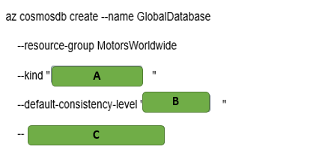

A)

1. GlobalDocumentDB
2. MongoDB
3. Parse

B)

1. Eventual
2. Session
3. Strong

C)

1. Enabable-automatic-failover
2. Enable-multiple-write-location
3. Enable-virtual-network

# Question50 Implement relational data stores - D

Your company is using various SQL and no-SQL databases in the Microsoft Azure cloud and on-premises to collect and store logistics data. However, business users struggle to build their Business Intelligence (BI) reports because of inconsistency and complexity of existing data stores.  
  
You plan to consolidate the required data and make it available for BI reporting from a centralized Azure SQL Data Warehouse. You plan to use PolyBase as a mechanism for the data load.  
  
As a first step, you automate the data extract from the source databases to Azure Data Lake Storage Gen2. You also create a new Azure SQL Data Warehouse resource and set up a service principal in Azure Active Directory (Azure AD).  
  
You need to define external tables in your Azure SQL Data Warehouse, so that PolyBase can understand where and how to access your extracted data files, before it can load the data.  
  
Which four actions should you perform in sequence? To answer, move the appropriate actions from the list of possible actions to the answer area and arrange them in the correct order.

Create a list in the correct order

Possible actions

Actions in order

* Create a clustered columnstore index.
* Execute DBCC OPENTRAN.
* Create a database master key.
* Create a database scoped credential.
* Create an external data source and external file format.
* Create an external table.

# Question51 Implement relational data stores – D -

You are a data engineer for a utility billing solutions company. Your company has five customers that use your company for utility billing. Each customer has different peak usage periods within the year. In the legacy environment, each customer has its own database. You deploy an Azure SQL Database elastic pool.  
  
You need to configure the number of data transaction units (DTUs) to minimize cost.

What should you do?

Choose the correct answer

Determine the number of total DTUs that are used by all five databases combined.

Determine the number of DTUs that are used by the largest database.

Determine the number of DTUs that are used by the database with the most transactions.

Determine the number of DTUs that are used by the database with the longest peak period.

# Question52 Implement relational data stores - D

You are a data engineer for your company. Your company is planning to upgrade a customer's web application to use a different user interface technology. You create an Azure SQL Database instance that the developers will use while developing the application. Developers must only be able to access the database while on the company's premises.  
  
You need to configure the database to meet these requirements.  
  
What should you do?

Choose the correct answer

Run the New-AzSqlServerFirewallRule PowerShell cmdlet.

Add role assignments on the Access control (IAM) page of the Azure portal.

Run the az sql db audit-policy Azure CLI command.

Set the Allow access to Azure services setting to off in the Azure portal.

# Question53 Implement relational data stores - D

You are a data engineer for your company. Your company has an on-premises SQL Server instance that contains 16 databases. Four of the databases require Common Language Runtime (CLR) features.  
  
You must be able to manage each database separately because each database has its own resource needs. You plan to migrate these databases to Azure. You want to migrate the databases by using a backup and restore process by using SQL commands.  
  
You need to choose the most appropriate deployment option to migrate the databases.  
  
What should you use?

Choose the correct answer

Azure Cosmos DB with the Table API

Azure Cosmos DB with the SQL (DocumentDB) API

Azure SQL Database managed instance

Azure SQL Database with an elastic pool

# Question54 Implement relational data stores – D -

You are a data engineer for your company. You deploy an Azure SQL Database instance with the single database deployment option. You want to give an existing user named Sam administrative rights to the database. Sam must be able to add and remove other users.  
  
You need to complete the T-SQL command.  
  
How should you complete the command? To answer, select the appropriate options from the drop-down menus.

Choose the correct options

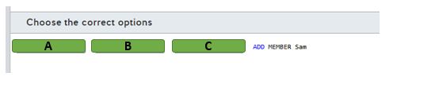

A)

1. Alter
2. Create
3. Grant

B)

1. LOGIN
2. ROLE
3. USER

C)

1. db_datareader
2. db_datawrite
3. db_owner

# Question55 Implement relational data stores-

You are a data engineer for your company. You create an Azure SQL Database server named autoone. You want to deploy two databases to this server. You want to allow both databases to share the resources provided by the server.  
  
How should you complete the commands? To answer, select the appropriate options from the drop-down menus.

az <<< A >>> create -n shared -s autoone  
az <<< B >>> create -n database1 -s autoone -- <<< C >>> shared  
az <<< D >>> create -n database2 -s autoone -- <<< E >>> shared

**<<< A >>> Options**

1. CosmosDB

2. SQL Elastic-Pool

3. SQL DB

**<<< B >>> Options**

1. CosmosDB database

2. sql db

3. sql elastic-pool

**<<< C >>> Options**

1. elastic-pool

2. zone-redundant

**<<< D >>> Options**

1. CosmosDB

2. SQL Elastic-Pool

3. SQL DB

**<<< E >>> Options**

1. elastic-pool

2. zone-redundant

Choose the correct options

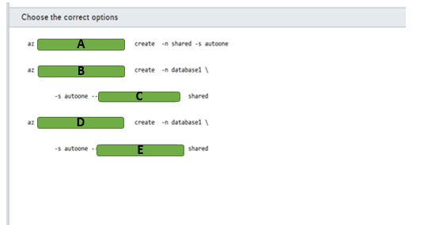

A)

1. Cosmodb
2. Sql elastic-pool
3. Sql db

B)

1. Cosmodb database
2. Sql db
3. Sql elastic pool

C)

1. Elastic pool
2. Zone-redundant

D)

1. Cosmodb database
2. Sql db
3. Elastic pool

E)

1. Elastic-pool
2. Zone-redundant

# Question56 Implement relational data stores -

You are a data engineer for your company. You create an Azure SQL Data Warehouse instance to house inventory data for 30 stores. There are approximately 10,000 products among the stores, with each distinct type of product having a different stock keeping unit (SKU). The inventory data will be captured every Friday. Friday updates cause massive changes to inventory data. You want to shard the data to improve performance.  
  
You need to write a T-SQL statement to generate the table.  
  
How should you complete the statement? To answer, select the appropriate code segments from the drop-down menus.

Choose the correct options

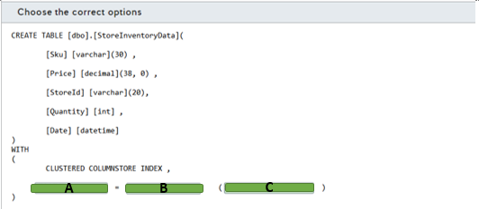

A)

1. Distribution
2. Partition

B)

1. HASH
2. REPLICATE
3. ROUND_ROBIN

C)

1. Sku
2. StoreID

# Question57 Implement relational data stores-

You are a data engineer for your company. You create an Azure SQL Data Warehouse instance to house inventory data for 30 stores. You want to shard the store data to improve performance when accessing store data. The size of the data is less than 200 megabytes (MB).  
  
You need to write a T-SQL statement to generate the store table.  
  
How should you complete the statement? To answer, select the appropriate code segments from the drop-down menus.

Choose the correct options

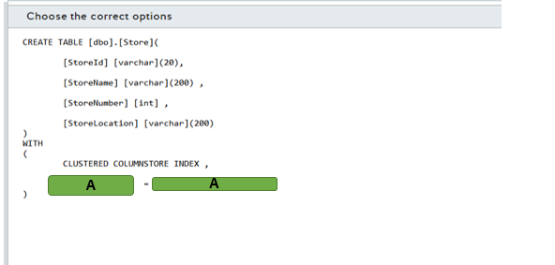

A)

1. DISTRIBUTION
2. PARTITION

B)

1. HASH(StoreID)
2. REPLICATE
3. ROUND_ROBIN

# Question58 Implement relational data stores-

You are a data engineer for your company. You create an Azure SQL Data Warehouse instance to house inventory data for 1000 stores. Each store has a distinct store number. You want to shard the store data to improve performance when accessing store data. You want to ensure that the data is evenly sharded across compute nodes.  
  
You need to write a T-SQL statement to generate the store table.  
  
How should you complete the statement? To answer, select the appropriate code segments from the drop-down menus.

Choose the correct options

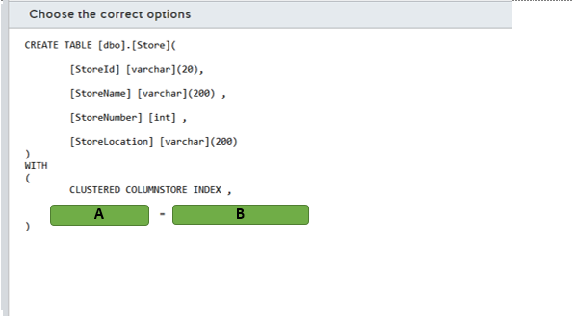

A)

1. DISTRIBUTION
2. PARTITION

B)

1. HASH (Store Number)
2. REPLICATE
3. ROUND_ROBIN

# Question59 Implement relational data stores -

You are a data engineer for your company. You create an Azure Data Warehouse database that uses round robin distribution. You write the following query to retrieve store sales data:  
  
SELECT S.[Amount] AS [Sales], ST.[Name] FROM [FactSalesByStore] AS S JOIN [DimStore] AS ST ON S.[StoreId] = ST.[StoreId]  
  
This query returns over 200,000 records, and it runs slowly. There are over 50,000 stores.  
  
You need to improve the performance of this query.  
  
What should you do?  
  
For each of the following statements, select Yes if you should perform the task. Otherwise, select No.

|  |  |  |
| --- | --- | --- |
| **Statement** | **Yes** | **No** |
| Use hash distribution on StoreId for FactSalesByStore. |  |  |
| Use hash distribution on StoreId for DimStore. |  |  |
| Use replicated distribution for DimStore. |  |  |
| Use an outer join instead of an inner join. |  |  |

# Question60 Implement relational data stores -

You are a data engineer for your company. An Azure blob storage container contains a large comma-separated-value (CSV) file. You want to load the data from that file into an Azure SQL Data Warehouse database table. You run the following SQL statements:  
  
CREATE MASTER KEY;  
  
CREATE EXTERNAL FILE FORMAT TextFile  
WITH (  
FORMAT_TYPE = DelimitedText,  
FORMAT_OPTIONS (FIELD_TERMINATOR = ',')  
);  
  
You need to run four additional SQL statements to load the data from the blob container.   
  
Which four SQL statements should you run? To answer, move the appropriate statements from the list of possible statements to the answer area and arrange them in the correct order.

Create a list in the correct order

Possible SQL statements

SQL statements in order

* CREATE DATABASE
* CREATE DATABASE SCOPED CREDENTIAL
* CREATE EXTERNAL DATA SOURCE
* CREATE EXTERNAL TABLE
* CREATE TABLE

# Question61 Implement relational data stores -

You manage your company’s Manufacturing Execution Solution (MES), which stores data in an Azure SQL Database.  
  
Because of a recent acquisition, you are asked to move the Azure SQL Database to another Azure region, so that the data resides closer to the manufacturing sites.  
  
You need to move the Azure SQL Database to the new region and delete the original Azure SQL Database without losing data.  
  
Which five actions should you perform in sequence? To answer, move the appropriate actions from the list of possible actions to the answer area and arrange them in the correct order.

Create a list in the correct order

Possible actions

Actions in order

* Monitor the sync process with the Get-AzSqlDatabaseFailoverGroup cmdlet and verify that its ReplicationState is equal to 0.
* Execute the Switch-AzSqlDatabaseFailoverGroup cmdlet by using the failover group’s read-write listener endpoint.
* Create a failover group and add the original Azure SQL Database.
* Monitor the sync process with the Get-AzSqlDatabaseFailoverGroup cmdlet and verify that its ReplicationState is equal to 2.
* Execute the Switch-AzSqlDatabaseFailoverGroup cmdlet by using the failover group’s read-only listener endpoint.
* With the NSLOOKUP command, verify the swap of IP addresses between the failover group’s read-write and read-only listeners.
* Delete the failover group and the original Azure SQL Database.

# Question62 Implement relational data stores -

You are deploying a new e-commerce solution in the Microsoft Azure environment that uses Azure SQL Database as its relational data store.  
  
As a part of the business continuity plan, you enable active geo-replication of the primary database to the secondary database in another Azure region.  
  
The Marketing team wants you to update the price list in Azure SQL Database shortly after the announcement of the new product ranges.  
  
You need to ensure that the price changes made in the primary database are replicated synchronously to the secondary database.

What should you do?

Choose the correct answer

Run the Get-AzSqlDatabaseReplicationLink Az PowerShell cmdlet after the change, using the connection string of the primary database.

Call the sp_wait_for_database_copy_sync procedure in the primary database after the change.

Call the sp_wait_for_database_copy_sync procedure in the secondary database after the change.

Verify in the sys.geo_replication_links view of Azure SQL database that the replication_state field of the secondary database record is set to 1.

# Question63 Implement relational data stores -

You manage an Azure SQL database hosted in the Central US Azure region.  
  
You need to synchronize the database with another Azure SQL Database instance that will be created in the East US Azure region. These databases will be used by a distributed application with write and read permission.  
  
You need to perform an initial data sync with the new database with minimal downtime and enable bi-directional sync after the initial sync.

Choose the correct answer

Azure SQL Data Sync

Azure SQL active geo-replication

Azure Database Migration Service

Data Migration Assistant (DMA)

# Question64 Implement relational data stores -

Your company manages a modern data warehouse solution. Part of this solution consists in an Azure SQL Data Warehouse and Azure Data Lake Storage Gen2.   
  
You need to configure PolyBase to load data from Azure Data Lake Storage Gen2 in a fact table named FactCarSales. This solution should not use service principals in Azure Active Directory (Azure AD).   
  
Which five actions should you perform in sequence? To answer, move the appropriate actions from the list of possible actions to the answer area and arrange them in the correct order.

Create a list in the correct order

Possible actions

Actions in order

* Create an external data source with the BLOB_STORAGE type.
* Create a scoped credential with the Client Id and OAuth 2.0 token endpoint.
* Create a scoped credential with the Azure storage account key.
* Create an external data source with the HADOOP type.
* Create an external file format.
* Create an external table.
* Load the data into the FactCarSales table.

# Question65 Implement relational data stores -

Your company is planning to migrate an on-premises data warehouse to Azure SQL Data Warehouse.   
  
Some SQL Data Warehouse tables need special attention before the migration:

* There is a large fact table named FactSales with 5 terabytes (TB). Queries involving this table use a primary key defined in the SaleKey column to retrieve data.
* A dimension table named DimBusinessUnits with 200 megabytes (MB) is used by almost all reports.
* A staging table named StagingFactSales is used during the extract, transform, and load (ETL) process to load new data to the FactSales table.

You need to migrate these tables and configure the appropriate distribution strategy for each table to optimize query performance.   
  
Which distribution strategy should you use? To answer, drag the appropriate distribution to the correct table. Each distribution may be used once, more than once, or not at all.

Drag and drop the answers

https://pts.measureup.com/web/instances/MUP/assets/images/DP-200/DP-200_65256/gsDP-200_013c.gif

https://pts.measureup.com/web/instances/MUP/assets/images/DP-200/DP-200_65256/gsDP-200_013b.gif

https://pts.measureup.com/web/instances/MUP/assets/images/DP-200/DP-200_65256/gsDP-200_013a.gif

https://pts.measureup.com/web/instances/MUP/assets/images/DP-200/DP-200_65256/gsDP-200_013c.gif

https://pts.measureup.com/web/instances/MUP/assets/images/DP-200/DP-200_65256/gsDP-200_013b.gif

https://pts.measureup.com/web/instances/MUP/assets/images/DP-200/DP-200_65256/gsDP-200_013a.gif

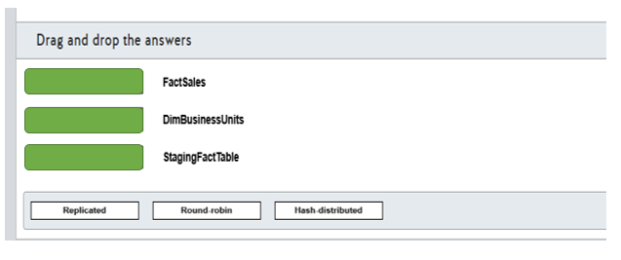

# Question66 Implement relational data stores-

Your team is implementing a new Azure SQL Data Warehouse solution in Azure.  
  
You need to use PolyBase to load data from a parquet file stored in an Azure Blob Storage in a table named FactSaleOrders.  
  
You need to configure the Azure SQL Data Warehouse to receive the data.  
  
Which five actions should you perform? To answer, move the appropriate actions from the list of possible actions to the answer area and arrange them in any order.

Create a list in any order

Possible actions

Actions to perform

* Load the parquet file into a staging table.
* Enable Transparent Data Encryption (TDE).
* Enable PolyBase support with the sp_configure command.
* Create a database master key.
* Create an external data source for Azure Blob Storage.
* Create an external table.
* Create an external file format for parquet file.
* Load the data in the FactSaleOrders table using T-SQL.

# Question67 Implement relational data stores-

Your company is provisioning multiple Azure SQL managed instances for an automotive industry application. The application must be resilient in case of an outage impacting an Azure region.  
  
You create a primary instance in the West US region named AutoInsdustry and a secondary instance in the East US region named AutoIndustrySecondary. The instances are provisioned in a resource group named AutoProduction.  
  
You need to implement an auto-failover group for database disaster recovery.  
  
How should you complete the PowerShell cmdlet? To answer, select the appropriate options from the drop-down menus.

Choose the correct options

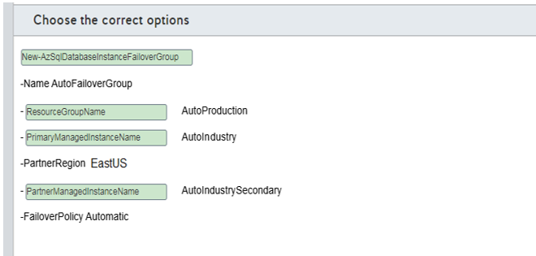

A)

1. New-AzSqlDatabaseFailoverGroup
2. New-AzSqlDatabaseInstanceFailoverGroup
3. Set-AzSqlDatabaseFailoverGroup

B)

1. PartnerManagedInstanceName
2. PrimaryManagedInstanceName
3. ResourceGroupName

C)

1. PartnerManagedInstanceName
2. PrimaryManagedInstanceName
3. ResourceGroupName

D)

1. PartnerManagedInstanceName
2. PrimaryManagedInstanceName
3. ResourceGroupName

# Question68 Implement relational data stores-

You are creating tables for Azure Synapse Analytics.  
  
You need to choose the appropriate types of tables for various needs.  
  
Which table option should you use in the following cases? To answer, drag the appropriate table option to each table category. A table option may be used once, more than once, or not at all.

Drag and drop the answers

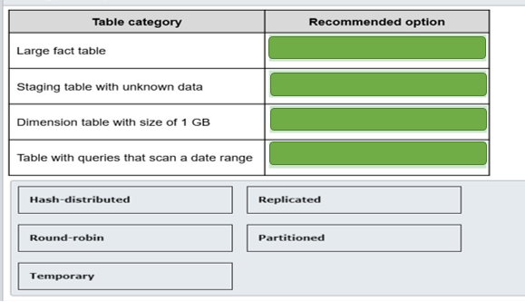

# Question69 Implement relational data stores-

You have an Azure Synapse Analytics database.  
  
You need a list of all hash distributed tables. The list must include the table name and the column name of the distribution column.  
  
Which three catalog views do you need to join in a query? Each correct answer presents part of the solution.

Choose the correct answers

sys.columns

sys.pdw_table_distribution_properties

sys.pdw_distributions

sys.pdw_column_distribution_properties

sys.pdw_nodes_columns

sys.tables

# Question70 Implement relational data stores-

You have a table named Sales in Azure Synapse Analytics SQL pool with the following definition

CREATE TABLE Sales (

ID [int] identity NOT NULL,

CustomerKey [int] NOT NULL,

Amount [money] NOT NULL,

Date [date] NOT NULL)

WITH

(DISTRIBUTION = HASH (CustomerKey),

PARTITION ( [Date] RANGE RIGHT

FOR VALUES ('2018-01-01', '2019-01-01', '2020-01-01', '2021-01-01' )));

The table does not contain dates after the year 2020.  
  
You need to archive the oldest partition (with dates before January 1, 2018). The archive table does not exist, and the name should be SalesHistory.  
After archiving the old data, you need to add a partition to the Sales table for the next year.  
  
Which four actions should you perform in sequence? To answer, move the appropriate actions from the list of actions to the answer area and arrange them in the correct order.

Create a list in the correct order

Possible actions

Actions in order

* Create the SalesHistory table with the same column definitions, data distribution and partition boundaries as the Sales table.  
  Create a check constraint on the Date column limiting the dates to smaller than '2018-01-01'.
* Switch partition 1 of the Sales table to partition 0 of the SalesHistory table.
* Create a new partition in the SalesHistory table with this command:  
  ALTER TABLE SalesHistory SPLIT RANGE ('2022-01-01');
* Create the SalesHistory table with the same column definitions and data distribution as the Sales table. Include one partition boundary as '2018-01-01'.
* Switch partition 1 of the Sales table to partition 1 of the SalesHistory table.
* Remove the boundary value '2018-01-01' in the Sales table by using:  
  ALTER TABLE Sales MERGE RANGE ('2018-01-01');
* Create a new partition in the Sales table with this command:  
  ALTER TABLE Sales SPLIT RANGE ('2022-01-01');

# Question71 - Manage data security-

Your company stores your consumer contact details in an Azure SQL Database. Data is encrypted at rest with the default Microsoft-managed transparent data encryption (TDE).  
  
Because of the company’s new security policy, you are asked to re-encrypt consumer database with your company’s own asymmetric key and enable auditing on its use.  
  
To support this, you set up a new Azure Key Vault and import a custom encryption key into it.  
  
You need to enable TDE with the new custom key from Azure Key Vault. You will use PowerShell cmdlets, not Azure Portal, for this configuration.  
  
Which four actions should you perform in sequence? To answer, move the appropriate actions from the list of possible actions to the answer area and arrange them in the correct order.

Create a list in the correct order

Possible actions

Actions in order

* Export an Azure SQL Database to a BACPAC file.
* Import a BACPAC file to an Azure SQL Database.
* Assign an Azure AD identity to the Azure SQL Database server.
* Grant Key Vault permissions to the Azure SQL Database server.
* Add the Key Vault key to the Azure SQL Database server and set it as TDE Protector.
* Turn on TDE.

# Question72- Manage data security-

You are a data engineer for a law firm. You create the following Azure SQL Database table:  
  
CREATE TABLE [Case]  
(  
  [CaseNumber] [int],  
  [Attorney] [sysname],  
  [Type] [varchar] (50),  
  [Docket] [varchar] (10)  
)  
  
Each attorney has a database user account. The Attorney column represents a database user account. You create the following function:  
  
CREATE FUNCTION attorney_cases(@Attorney as sysname)  
RETURNS TABLE  
WITH SCHEMABINDING  
AS  
RETURN SELECT 1 as retVal WHERE USER_NAME() = @Attorney  
  
You need to write a query that performs the following:

* Enforce row-level security on the Case table.
* Ensure that rows are returned only for the attorney performing the query.

You need to construct the query.  
  
How should you complete the SQL statement? To answer, select the appropriate code segments from the drop-down menus.

Choose the correct options

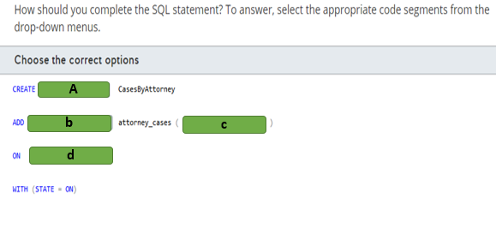

A)

1. FILTER PREDICATE
2. FUNCTION
3. SECURITY POLICY

B)

1. FILTER PREDICATE dbo
2. SECURITY POLICY

C)

1. Attorney
2. [dbo].[Case]
3. CURRENT_USER

D)

1. Attorney
2. [dbo].[Case]

# Question73- Manage data security-

You are a data engineer. The following query creates a table in an Azure SQL Database:  
  
CREATE TABLE Employee (  
  [ID] [int],  
  [GivenName] [varchar](50)  
    COLLATE Latin1_General_BIN2  
    ENCRYPTED WITH (COLUMN_ENCRYPTION_KEY = EmployeeCEK,  
    ENCRYPTION_TYPE = RANDOMIZED ,   
    ALGORITHM = 'AEAD_AES_256_CBC_HMAC_SHA_256'),  
  [SurName] [varchar](50),  
  [SSN] [char](9)   
    COLLATE Latin1_General_BIN2  
    ENCRYPTED WITH (COLUMN_ENCRYPTION_KEY = EmployeeCEK,  
    ENCRYPTION_TYPE = DETERMINISTIC ,   
    ALGORITHM = 'AEAD_AES_256_CBC_HMAC_SHA_256'),  
)  
  
You write the following query to insert data into the table:  
  
DECLARE @SSN = '123456789';  
INSERT INTO Employee(ID, GivenName, SurName, SSN)  
SELECT 1, 'Sam', 'Jack', @SSN  
  
You need to determine which queries will return data when you enable Always Encrypted and Parameterization for Always Encrypted.  
  
For each of the following queries, select Yes if the query returns data. Otherwise, select No.

|  |  |  |
| --- | --- | --- |
| **Query** | **Yes** | **No** |
| DECLARE @SSN char(9) = '123456789'; SELECT GivenName FROM Employee WHERE SSN=@SSN |  |  |
| DECLARE @Name varchar(50) = 'Sam'; SELECT SSN FROM Employee WHERE GivenName = @Name |  |  |
| SELECT GivenName, SSN FROM Employee |  |  |

# Question74- Manage data security - D

You are a data engineer. You create a table with the following query:  
  
CREATE TABLE License (  
  [ID] int,  
  [Number] char(9)  MASKED WITH (FUNCTION = 'partial(3, "xxxxx", 1)') NULL,  
  [GivenName] varchar(20),  
  [SurName] varchar(20)  
)  
  
You insert data by using the following query:  
  
INSERT INTO License (ID, Number, GivenName, SurName)  
SELECT 1, '111222333', 'Sam', 'Jack'  
  
You then run the following query to return data:  
  
SELECT Number FROM License where ID=1  
  
You need to determine which value is returned from the query.  
  
Which value is returned?

Choose the correct answer

22233

xxx22233x

1113

111xxxxx3

# Question75- Manage data security - D

You are a data engineer for your company. You manage a SQL Server 2019 database on an Azure virtual machine (VM). A developer at the company needs to connect to the database from a client application. The client application passes the credentials in the connection string.  
  
You need to allow the developer to return decrypted values for encrypted columns.  
  
Which parameter should the developer specify in the connection string?

Choose the correct answer

Integrated Security = false

Column Encryption Setting = enabled

Integrated Security = true

Column Encryption Setting = disabled

# Question76- Manage data security-

You are a data engineer for your company. You manage a SQL Server 2019 database on an Azure virtual machine (VM). You configure the database to use Always Encrypted.  
  
You need to grant a user named Sam permission to manage the key that is used to encrypt and decrypt column encryption keys.  
  
How should you complete the SQL statement? To answer, select the appropriate code segments from the drop-down menus.

Choose the correct options

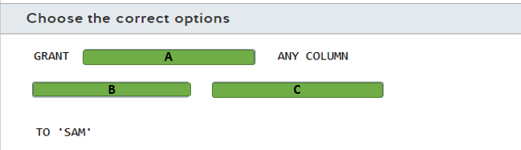

A)

1. ALTER
2. VIEW

B)

1. ENCRYPTION
2. MASTER

C)

1. KEY
2. KEY DEFINATION

# Question77- Manage data security-

You are a data engineer for your company. You manage a SQL Server 2019 database on an Azure virtual machine (VM). You configure the database to use Always Encrypted.  
  
You need to grant a user named Sam permission to query encrypted columns.  
  
Which minimal permissions should you grant to Sam? For each of the following statements, select Yes if the statement is true. Otherwise, select No.

|  |  |  |
| --- | --- | --- |
| **Statement** | **Yes** | **No** |
| Grant the ALTER ANY COLUMN MASTER KEY permission. |  |  |
| Grant the ALTER ANY COLUMN ENCRYPTION KEY permission. |  |  |
| Grant the VIEW ANY COLUMN MASTER KEY DEFINITION permission. |  |  |
| Grant the VIEW ANY COLUMN ENCRYPTION KEY DEFINITION permission. |  |  |

# Question78 - Manage data security-

You are a data engineer for your company. Your company is developing a new application that uses Azure SQL Database. You are designing a security policy to help keep the company's data secure.  
  
You need to provide instructions to developers on how to prevent SQL injection attacks.  
  
For each of the following statements, select Yes if the statement is true. Otherwise, select No.

|  |  |  |
| --- | --- | --- |
| **Statement** | **Yes** | **No** |
| Eliminate the use of stored procedures. |  |  |
| Use ad-hoc queries. |  |  |
| Validate user input. |  |  |

# Question79 - Manage data security-

You manage an Azure SQL Database that has the following table definition:  
  
CREATE TABLE [Order]   
(  
  OrderID int,  
  SalesPerson sysname,  
  ProductID int,  
  Quantity int,  
  Price decimal(8, 2)   
);  
  
The SalesPerson field represents the database user of a sales person responsible for the order. A sales person should only be able to query his or her own orders. You want to use a security policy and row-level security to enforce this.  
  
You need to define the security policy predicate.  
  
How should you complete the code? To answer, select the appropriate code segments from the drop-down menus.

Choose the correct options

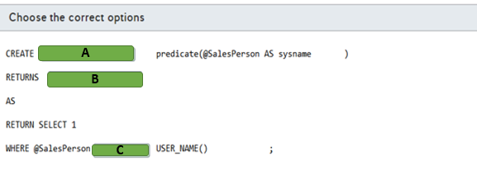

A)

1. FUNCTION
2. TABLE

B)

1. FUNCTION
2. TABLE

C)

1. =
2. <>

# Question80- Manage data security - D

You are a data engineer for an Azure SQL Database. You write the following SQL statements:  
  
CREATE TABLE Customer (  
  CustomerID int IDENTITY PRIMARY KEY,  
  GivenName varchar(100) MASKED WITH (FUNCTION = 'partial(2,"XX",0)') NULL,  
  SurName varchar(100) NOT NULL,  
  Phone varchar(12) MASKED WITH (FUNCTION = 'default()')  
);  
  
INSERT Customer (GivenName, SurName, Phone) VALUES ('Sammy', 'Jack', '555.111.2222');  
  
SELECT * FROM Customer;  
  
You need to determine what is returned by the SELECT query?  
  
What data is returned?

Choose the correct answer

1 SaXX Jack xxxx

1 XXXX Jack XXX.XXX.XXXX

1 SaXX Jack XXX.XXX.2222

1 xx Jack XXX.XXX.2222

# Question81- Manage data security-

Your company’s accounting system uses Azure SQL Database as a backend. You enable geographic redundancy between the primary and secondary Azure SQL Database instances hosted in two different Azure regions.  
  
Your corporate IT security policy dictates that, instead of Microsoft-managed keys, you should use your own asymmetric keys for Azure SQL Database Transparent Data Encryption (TDE). You deploy Azure Key Vaults in both Azure regions, create a new encryption key (TDE protector) in the primary region’s Key Vault, and clone it into the secondary region’s Key Vault via backup and restore.  
  
You need to configure TDE in your geo-redundant Azure SQL Database environment to use your TDE protector. You should perform these tasks in Azure portal.  
  
Which four actions should you perform in sequence? To answer, move the appropriate actions from the list of possible actions to the answer area and arrange them in the correct order.

Create a list in the correct order

Possible actions

Actions in order

* On the primary Azure SQL Database server, set the Advanced Data Security feature to Off.
* On the secondary Azure SQL Database server, set the Advanced Data Security feature to Off.
* On the primary Azure SQL Database server, set the Advanced Data Security feature to On.
* On the secondary Azure SQL Database server, assign a Key Vault from the same region.
* On the secondary Azure SQL Database server, assign the TDE protector.
* On the primary Azure SQL Database server, assign a Key Vault from the same region.
* On the primary Azure SQL Database server, assign the TDE protector.

# Question82 Implement non-relational data stores - D

You are implementing a data engineering solution for your company. You plan to use Azure table storage to store receipts. Each receipt contains a date, a category, and a unique number. Over 50 percent of the receipts have the same category. These are the 10 most popular categories. Approximately five percent of the receipts have the same date.  
  
You need to define the row key and the partition key scheme.  
  
For each of the following statements, select Yes if you should perform the task. Otherwise, select No.

|  |  |  |
| --- | --- | --- |
| **Statement** | **Yes** | **No** |
| Specify the date as a partition key. |  |  |
| Specify the category as a partition key. |  |  |
| Specify the unique number as the row key. |  |  |

# Question83- Manage data security

You work for a call center company that uses Azure SQL Database. The database stores customer credit card numbers in a table named PaymentInfo. Telemarketing attendants will consult this table to help with customer payment support.  
  
You need to implement dynamic data masking (DDM) in the PaymentInfo table to mask credit card numbers for telemarketing attendants. Only the two first digits and the last four digits should be visible.  
  
How should you complete the T-SQL query? To answer, select the appropriate options from the drop-down menus.

Choose the correct options

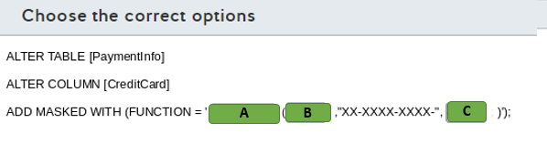

A)

1. Default
2. Partial
3. random

B)

1. 0
2. 2
3. 4

C)

1. 0
2. 2
3. 4

# Question84- Manage data security

You are a data engineer. You manage three SQL Server databases in Azure. The databases must meet the following security requirements:  
  
Database 1 - Only specific columns in the 10 tables must be encrypted.  
Database 2 - All data in the entire database must be encrypted at rest.  
Database 3 - Data must be encrypted while in transit between the client application and Azure.  
  
You need to determine which encryption technology to use for each database.  
  
Which encryption technology should you use for each database? To answer, choose the correct encryption technology from the drop-down menus.

Choose the correct options

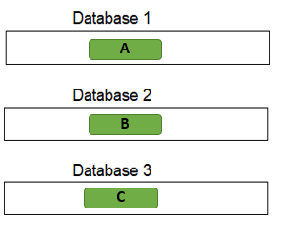

A)

1. Always Encrypted
2. Transparent Data Encryption

B)

1. Always Encrypted
2. Transparent Data Encryption

C)

1. Always Encrypted
2. Transparent Data Encryption

# Question85- Manage data security

You manage an Azure SQL database for a financial application.   
  
You need to configure a dynamic data mask to completely mask the data of a specific varchar field.   
  
Which masking function should you use?

Choose the correct answer

Email

Default

Partial

Random

# Question86- Manage data security

You manage an Azure SQL Database for a mission-critical application named ElectronicsProduction. The database stores personal information about your users.  
  
You need to implement Transparent Data Encryption (TDE) with a customer-managed encryption key in this database. You assign an Azure Active Directory (AD) identity in Azure SQL Database.  
  
Which five actions should you perform in sequence? To answer, move the appropriate actions from the list of possible actions to the answer area and arrange them in the correct order.

Create a list in the correct order

Possible actions

Actions in order

* Create a master key in the master database.
* Create a server certificate using the master key.
* Create a database encryption key from the certificate in ElectronicsProduction.
* Create an Azure Key Vault and generate a new key.
* Grant Key Vault permissions to the Azure SQL Database server.
* Add the Key Vault key to the Azure SQL Database server.
* Set the TDE Protector to use the Key Vault key.
* Enable encryption in the ElectronicsProduction database.

# Question87 Implement non-relational data stores - D

You are a data engineer for your company. You use the following Azure CLI commands to create an Azure Cosmos DB account. You plan to use this account to store sales data.  
  
az cosmosdb create --resource-group 'sales-rg' --name 'sales' --kind GlobalDocumentDB \  
--locations regionName="South Central US" failoverPriority=0 \  
--locations regionName="North Central US" failoverPriority=1 \  
--default-consistency-level "Strong" --enable-multiple-write-locations true  
  
You need to answer questions regarding sales data queries and updates.  
  
For each of the following statements, select Yes if the statement is true. Otherwise, select No.

|  |  |  |
| --- | --- | --- |
| **Statement** | **Yes** | **No** |
| You can query data by using Gremlin API. |  |  |
| A client can see partial writes of a sales data record by default. |  |  |
| A client can set the consistency level to Eventual Consistency at connection time. |  |  |
| A client can set a different consistency level during each request to sales data. |  |  |

# Question88 - Develop batch processing solutions-

You are a data engineer for an Azure SQL Data Warehouse. You want to import data to a database from a large pipe-separated file in an Azure blob storage container.  
  
You need to create the connection to the container.  
  
How should you complete the T-SQL statement? To answer, select the appropriate code segments from the drop-down menus.

Choose the correct options

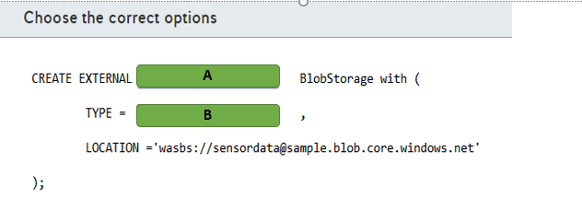

A)

1. DATA SOURCE
2. FILE FORMAT
3. TABLE

B)

1. BLOB_STORAGE
2. HADOOP

# Question89 - Develop batch processing solutions – D -

You are a data architect for your company. Your team must analyze large CSV files from Azure blob storage daily. The team must be able to generate pie charts and bar charts without writing graphics code. The data engineers on the team know Python and SQL.  
  
You need to recommend a solution for analyzing the file.  
  
What should you recommend?

Choose the correct answer

Azure Databricks

Azure Data Lake

Stream Analytics

Log Analytics

# Question90 - Develop batch processing solutions-

You are a data engineer for your company. You create an Azure Databricks account. You add code to a notebook cell to import data from a comma-separated-value (CSV) file named sensordata.csv into a folder named /tmp.  
  
You need to copy the data to an Azure Data Lake Storage Gen 1 account.   
  
Which command should you run?

Choose the correct answer

dbutils.fs.ls("copy /tmp/sensordata.csv abfss://samplefs@sample.dfs.core.windows.net/")

spark.read.json("abfss://tmp/sensordata.csv@sample.dfs.core.windows.net")

dbutils.fs.cp("file:///tmp/sensordata.csv", "abfss://samplefs@sample.dfs.core.windows.net/")

spark.conf.set("tmp/sensordata.csv", "abfss://samplefs@sample.dfs.core.windows.net/")

# Question91 - Develop batch processing solutions – D -

You are a data engineer for your company. You create an Azure Databricks account by using the Azure portal. You plan to ingest data from blob storage into Databricks. You import a notebook from Github.  
  
You need to create the next resource so that you can run code to ingest the data.  
  
What should you create next?

Choose the correct answer

Cosmos DB account

SQL Data Warehouse instance

Spark cluster

Master key

# Question92 Implement non-relational data stores - D

You are a data engineer for an exam development company. You create an Azure Cosmos DB account that uses the session consistency level. You create a database and collection that allows exam developers to create and store exam content.  
  
Developer A and Developer B reside in Virginia, United States. Developer C resides in Madrid, Spain. At 12:00, the question entity has its difficulty attribute set to Hard. All three developers read the value Hard. Developer A then changes the difficulty attribute to Medium. All three developers then immediately read the entity before replication occurs.  
  
You need to answer questions regarding the reads.  
  
For each of the following statements, select Yes if the statement is true. Otherwise, select No.

|  |  |  |
| --- | --- | --- |
| **Statement** | **Yes** | **No** |
| Developer A will read Medium. |  |  |
| Developer B will read Medium. |  |  |
| Developer C will read Hard. |  |  |

# Question93 - Develop batch processing solutions - D

You are implementing a data engineering solution for your company. Every Thursday night, a third-party company loads shipping data to an Azure blob storage container. This data is in the form of large comma-separated-value (CSV) files. You want to run analytics on that data to automatically generate bar charts that you can visualize. If the data looks good visually, you want to import that data into a SQL Data Warehouse database table.  
  
You need to schedule a job to generate the charts.  
  
What should you do?

Choose the correct answer

Create a scheduled WebJob.

Create a scheduled Azure Databricks job.

Create a scheduled runbook in Azure Automation.

Create a scheduled function.

# Question94 - Develop batch processing solutions-

You are a data engineer. You have an Azure Databricks account with an imported notebook. You also create an Azure data factory.  
  
You need to ensure that Data Factory can access Databricks.  
  
What should you create?

Choose the correct answer

An access policy on a blob storage container

A master key

A blob storage container

An access token

# Question95 - Develop batch processing solutions-

You are a data engineer. You use Azure Data Factory to copy and transform data from Azure blob storage to an on-premises server.  
  
You need to ensure that you can successfully copy data.  
  
Which two actions should you perform? Each correct answer presents part of the solution.

Choose the correct answers

Create a self-hosted integration runtime in Azure Data Factory UI.

Create an Azure integration runtime.

Install the self-hosted integration runtime on an Azure virtual machine (VM).

Install the self-hosted integration runtime on the local network.

Create an Azure-SSIS integration runtime.

# Question96 - Develop batch processing solutions-

You are migrating a corporate research analytical solution from an internal datacenter to Azure.  
  
200 TB of research data is currently stored in an on-premises Hadoop cluster. You plan to copy it to Azure Storage. Your internal datacenter is connected to your Azure Virtual Network (VNet) with Express Route private peering. The Azure Storage service endpoint is accessible from the same VNet.  
  
Corporate policy dictates that the research data cannot be transferred over public internet.  
  
You need to securely migrate the research data online.   
  
What should you do?

Choose the correct answer

Transfer the data using Azure Data Box Heavy devices.

Transfer the data using Azure Data Box Disk devices.

Transfer the data using Azure Data Factory in distributed copy (DistCopy) mode, with an Azure Data Factory self-hosted Integration Runtime (IR) machine installed in the on-premises datacenter.

Transfer the data using Azure Data Factory in native Integration Runtime (IR) mode, with an Azure Data Factory self-hosted IR machine installed on the Azure VNet.

# Question97 - Develop batch processing solutions-

Your company is implementing a new Azure Databricks workspace.  
  
This environment should be able to access private data stored in Azure Data Lake Store Gen2. Credentials for Azure Databricks should be available in a secure way.  
  
You create a secret scope in the workspace and add the storage account key and a service principal secret.  
  
You need to configure a notebook in this workspace to read from Azure Data Lake Store Gen2.  
  
Which two actions should you perform? Each correct answer presents part of the solution.

Choose the correct answers

Generate a Shared Access Signature (SAS).

Read from the storage account using the RDD API.

Mount a filesystem using a service principal.

Configure the storage account key with spark.conf.set().

Configure the storage account key with spark.sparkContext.hadoopConfiguration().

# Question98 - Develop batch processing solutions-

Your team is implementing event processing to handle real-time streaming data from Twitter.  
  
You configure an Azure Event hub named TweetStream to ingest the streaming data. You use Azure Databricks to analyze the streaming data from Event Hub. You create a new workbook named TweetAnalysis.  
  
You need to configure the TweetAnalysis workbook to connect with TweetStream.  
  
How should you complete the notebook code? To answer, select the appropriate options from the drop-down menus.

Choose the correct options

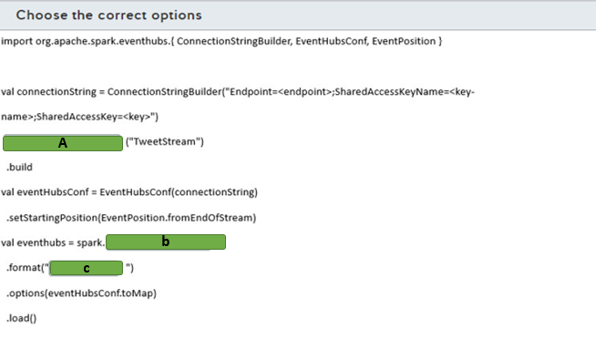

A)

1. setEventHubName
2. SetNamespaceName
3. SetSasKeyName

B)

1. Read
2. ReadStream
3. WriteStream

C)

1. EventHubs
2. Kinesis
3. memory

# Question99 - Develop batch processing solutions-

You work as a data engineer in a company that uses Azure Data Factory for data pipelines.  
  
The company needs to connect with an on-premises database and move data periodically to an Azure SQL Database. The data pipeline is allowed to run at specific, fixed-size time intervals.  
  
You need to implement the Azure Data Factory component to connect with the on-premises database and use the appropriate pipeline execution.  
  
Which component and execution should you use? To answer, select the appropriate options from the drop-down menus.

Choose the correct options

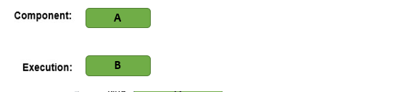

A)

1. Activity
2. Linked Service
3. Pipeline

B)

1. Manual
2. Scehdual
3. Tumbling window

# Question100 - Develop batch processing solutions-

Your company hosts an enterprise resource planning (ERP) system with an on-premises SQL Server configured with SQL Server Integration Services (SSIS) packages to extract data from the ERP to an on-premises SQL Server Data Warehouse.  
  
You need to integrate the SSIS packages with Azure Data Factory by configuring the self-hosted integration runtime (IR) as a proxy for Azure-SSIS IR. You already created an Azure Blob storage for the integration.  
  
Which five actions should you perform? To answer, move the appropriate actions from the list of possible actions to the answer area and arrange them in any order.

Create a list in any order

Possible actions

Actions to perform

* Install the self-hosted IR in the on-premises data warehouse.
* Create a linked service in Azure Data Factory with an on-premises data warehouse.
* Create a linked service in Azure Data Factory with Azure Blob Storage.
* Create an Azure-SSIS IR in Azure Data Factory.
* Install the self-hosted IR in the on-premises SSIS.
* Set up the self-hosted IR as a proxy for your Azure-SSIS IR.
* Register the self-hosted IR with the authentication key.

# Question101 - Develop batch processing solutions-

Your team manages a data pipeline in Azure Data Factory that is configured with an on-premises SQL server and an Azure SQL database as linked services.  
  
The data pipeline will be used to incrementally copy data from an on-premises SQL server table named Customers to an Azure SQL database. The Customers table was created with the T-SQL statement shown in the exhibit.  
  
You implement a watermark approach to load delta data from the Customers table to Azure SQL Database. You create the Watermark table and a stored procedure to update the watermark table in the on-premises table.  
  
You need to implement the activities in the data pipeline to incrementally copy data.  
  
Which four actions should you perform? To answer, move the appropriate actions from the list of possible actions to the answer area and arrange them in any order.

Create a list in any order

Possible actions

Actions to perform

* Look up the new watermark value in the Customers table from the PersonID field.
* Look up the old watermark value from the Customers table.
* Copy the delta data using the watermark values.
* Look up the new watermark value in the Customers table from the LastModifyTime field.
* Execute a stored procedure to update the watermarks in the Watermark table.
* Look up the old watermark value from the Watermark table.

# Question102 - Develop batch processing solutions-

You use a data pipeline in Azure Data Factory to move data from Azure Blob Storage to an Azure SQL Data Warehouse using PolyBase.  
  
The data is stored in a CSV file named zipCode.csv and has a structure as shown in the exhibit. The CSV file is stored in Azure Blob storage in a path named ZipCode inside a blob storage container.  
  
You need to complete the T-SQL query to ingest the data from Azure Blob Storage with PolyBase.  
  
How should you complete the code? To answer, select the appropriate options from the drop-down menus.

Choose the correct options

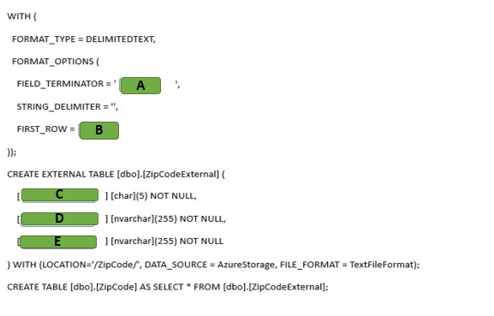

A)

1. ,
2. .
3. |

B)

1. 1
2. 2
3. 3

C)

1. City
2. Country
3. Zip code

D)

1. City
2. Country
3. Zip code

D)

1. City
2. Country
3. Zip code

# Question103 - Develop batch processing solutions-

You have an Azure Synapse Analytics SQL pool. You need to create two Azure Data Factory (ADF) pipelines to load data into the SQL pool.

* A pipeline to migrate data from SQL Server Analysis Services (SSAS)
* A pipeline for a daily incremental load from an Azure SQL Database

For each of the following statements, select Yes if the statement is true. Otherwise, select No.

|  |  |  |
| --- | --- | --- |
| **Statement** | **Yes** | **No** |
| You can use the SSAS data source in an ADF Copy Activity. |  |  |
| You can implement the incremental load from the Azure SQL Database by using the change tracking feature combined with an ADF Copy Activity. |  |  |
| An ADF Copy Activity can invoke the Polybase feature to load the Azure Synapse Analytics SQL pool. |  |  |

# Question104 - Develop batch processing solutions - D

You are working with Azure Data Factory.   
  
Sales data from two regions must be imported into an Azure Synapse Analytics SQL pool. The data is stored in two CSV files.  
  
You have the following requirements:

* All data from the CSV files must be stored in a single destination table.
* Duplicate records must be inserted into the destination table.

You need to implement a mapping data flow to import the data.  
  
Which data flow transformation should you use?

Choose the correct answer

Join

Union

Aggregate

Lookup

# Question105 Implement non-relational data stores -D

Users named Alan and Kerry are members of the Marketing Azure Active Directory (Azure AD) security group, set as a primary one for their Azure AD accounts. Kerry and another user named David are members of the Finance security group, set as a primary for David’s account.  
  
You set up a new directory in Azure Data Lake Storage and set the owning group to Finance. Kerry creates a new text file in that directory as an extract from the Sales database. Your audit report indicates that the access control list (ACL) for that file is set to 640 in the POSIX format.  
  
You need to determine what access permissions Alan, Kerry, and David all have to the newly uploaded text file.  
  
What permissions do they have? To answer, drag the appropriate permission option to each user’s ACL column. A permission option may be used once, more than once, or not at all.

Drag and drop the answers

https://pts.measureup.com/web/instances/MUP/assets/images/DP-200/DP-200_63632/ltMS_DP-200_SelectPlace_1(9).jpeg

https://pts.measureup.com/web/instances/MUP/assets/images/DP-200/DP-200_63632/ltMS_DP-200_SelectPlace_1(11).jpeg

https://pts.measureup.com/web/instances/MUP/assets/images/DP-200/DP-200_63632/ltMS_DP-200_SelectPlace_1(13).jpeg

https://pts.measureup.com/web/instances/MUP/assets/images/DP-200/DP-200_63632/ltMS_DP-200_SelectPlace_1(9).jpeg

https://pts.measureup.com/web/instances/MUP/assets/images/DP-200/DP-200_63632/ltMS_DP-200_SelectPlace_1(11).jpeg

https://pts.measureup.com/web/instances/MUP/assets/images/DP-200/DP-200_63632/ltMS_DP-200_SelectPlace_1(13).jpeg

https://pts.measureup.com/web/instances/MUP/assets/images/DP-200/DP-200_63632/ltMS_DP-200_SelectPlace_1(8).jpeg

https://pts.measureup.com/web/instances/MUP/assets/images/DP-200/DP-200_63632/ltMS_DP-200_SelectPlace_1(10).jpeg

https://pts.measureup.com/web/instances/MUP/assets/images/DP-200/DP-200_63632/ltMS_DP-200_SelectPlace_1(12).jpeg

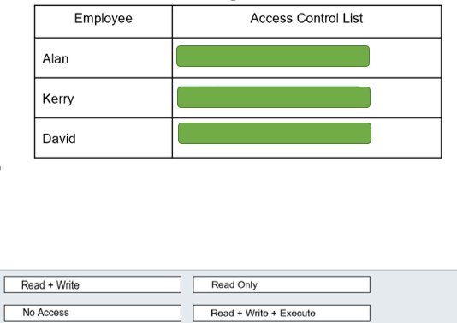

# Question106 Implement non-relational data stores - D

You are a data engineer for an insurance company. You create an Azure Cosmos DB account that uses the strong consistency level. You create a database and a collection that allows personnel to manage insurance claims. Employee A and Employee B reside in Virginia, United States. Employee C resides in Madrid, Spain. At 12:00, a claim entity has its status attribute set to Pending. Employee A then changes the status attribute to Closed. All three employees then immediately read the entity before it is committed and before synchronization occurs.  
  
You need to answer questions regarding the reads.  
  
To answer, select Yes if the statement is true. Otherwise, select No.

|  |  |  |
| --- | --- | --- |
| **Statement** | **Yes** | **No** |
| Employee A reads Closed. |  |  |
| Employee B reads Pending. |  |  |
| Employee C reads Pending. |  |  |

# Question107 Implement non-relational data stores - D

You are a data engineer for your company. You are creating an Azure Cosmos DB account to store an existing product catalog. The existing product catalog currently exists as a single Oracle database table. Approximately 20 percent of the columns in the table are empty.  
  
Each product type can have different attribute names and a different attribute count. You must be able to search the catalog by product id and category. You must be able to search for products in the Clothing category by size. You must be able to search for products in the Laptop category by CPU speed. You also must be able to query data by using the following syntax from a web application:  
  
SELECT p.productName FROM Products p  
  
You need to choose the most appropriate API.  
  
Which API should you choose?

SELECT p.productName FROM Products p  
  
You need to choose the most appropriate API.  
  
Which API should you choose?

Choose the correct answer

MongoDB API

Table API

Core SQL API

Gremlin API

# Question108 Develop streaming solutions - D

You are a data engineer for your company. You are creating a Stream Analytics query. You want to use a windowing function that allows you to capture events that repeat and that do not overlap. You also want to capture time periods when there are no events.  
  
You need to choose the appropriate windowing function.  
  
Which windowing function should you choose?

Choose the correct answer

Session

Tumbling

Sliding

Hopping

# Question109 Develop streaming solutions-

A car manufacturer implements an IoT solution in its production line. The solution uses Azure IoT Hub to connect and manage IoT devices. The IoT devices are capable of running Docker images.  
  
You need to deploy an Azure Stream Analytics job to provide real-time analytics.   
  
The solution must minimize latency and bandwidth usage between the job and IoT devices. The Stream Analytics job needs to stream events to the IoT Hub. In the future, an Azure function will be implemented to process data from the IoT Hub.  
  
Which five actions should you perform in sequence? To answer, move the appropriate actions from the list of possible actions to the answer area and arrange them in the correct order.

Create a list in the correct order

Possible actions

Actions in order

* Configure Streaming Units (SUs).
* Create a Stream Analytics job with cloud hosting.
* Create an Azure Blob Storage container.
* Create a Stream Analytics job with edge hosting.
* Configure the Azure Blob Storage container as save location for the job definition.
* Set up an IoT Edge environment on the IoT devices and add a Stream Analytics module.
* Configure routes in IoT Edge.

# Question110 Implement non-relational data stores - D

You are building a new CRM solution with Azure Cosmos DB as a backend. You plan to use an Apache TinkerPop compatible framework.  
  
Your consumers, promotions, and products will become vertices in your CRM’s graph structure, while the references to the events your consumers attended and the specific products they bought will form the graph’s edges.  
  
You need to choose the right API in Azure Cosmos DB to build the graph database algorithms.  
  
What should you do?

Choose the correct answer

Use Table API.

Use MongoDB API.

Use SQL API.

Use Cassandra API.

Use Gremlin API.

# Question111 Develop streaming solutions-

You need to implement an event processing solution using Azure Stream Analytics to analyze phone calls and identify fraudulent calls.  
  
This solution must ingest phone calls from an Azure Event hub, analyze the data in real time, and visualize the fraudulent calls with Power BI.  
  
You need to implement the Stream Analytics job.  
  
Which four actions should you perform? To answer, move the appropriate actions from the list of possible actions to the answer area and arrange them in any order.

Create a list in any order

Possible actions

Actions to perform

* Configure Azure Blob Storage as the reference input.
* Set up Azure Blob Storage as the stream output.
* Configure Azure Event Hubs as the stream input.
* Define a query to identify fraudulent calls.
* Set up Power BI as the stream output.
* Start the job.

# Question112 Develop streaming solutions-

Your company is implementing Azure Stream Analytics to analyze a continuous flow of data from a social media platform.  
  
This incoming social media data stream uses an Azure service that is compatible with Apache Kafka protocols and streams events in binary format. The social media platform provides a Schema Registry to define the data schema. The data stream platform is managed by the social media company.  
  
You need to create a new input stream in Azure Stream Analytics to directly consume the social media data stream.  
  
Which input stream type and event serialization format should you implement to meet the requirements? To answer, select the appropriate options from the drop-down menus.

Choose the correct options

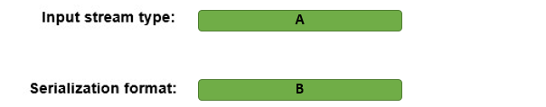

A)

1. Blob Storage
2. Event Hub
3. IOT Hub

B)

1. Avro
2. CSV
3. JSON

# Question113 Implement non-relational data stores - D

Your team is planning to use Azure Cosmos DB as the data store for a multi-region application.   
  
You need to choose a default consistency model with the lowest latency between the application and Cosmos DB.   
  
Which consistency model should you use?

Choose the correct answer

Eventual

Consistent Prefix

Session

Strong

Bounded Staleness

# Question114 Monitor data storage -

You are a data engineer. You manage an Azure SQL Database named Sample.  
  
You need to monitor performance by capturing a history of query plan changes over time.  
  
What should you do?

Choose the correct answer

Run the following SQL statement:  
  
ALTER DATABASE Sample SET QUERY_STORE = ON (OPERATION_MODE = READ_WRITE);

Open SQL Server Profiler from SQL Server Management Studio and choose the Performance statistics event.

Run the following SQL statement:  
  
CREATE STATISTICS Sample WITH FULLSCAN

Open SQL Server Profiler from SQL Server Management Studio and choose the Showplan All event.

# Question115 Monitor data storage-

You are a data engineer for your company. You manage a Microsoft SQL Server 2019 database that is hosted on an Azure virtual machine (VM) and used by an on-premises web application. The application is undergoing a major change. You consider using Query Store to examine performance before and after the change.  
  
You need to determine the scenarios where Query Store can help.  
  
For each of the following scenarios, select Yes if Query Store can help. Otherwise, select No.

|  |  |  |
| --- | --- | --- |
| **Scenario** | **Yes** | **No** |
| Creating more indexes on 10 tables |  |  |
| Adding additional databases for the web application |  |  |
| Increasing the size of the VM |  |  |

# Question116 Monitor data storage-

You manage an Azure SQL Data Warehouse. You want to use Dynamic Management Views (DMVs) to monitor your workloads.  
  
You need to find the top 10 longest running queries.  
  
Which view should you use?

Choose the correct answer

sys.dm_pdw_request_steps

sys.dm_pdw_exec_sessions

sys.dm_pdw_sql_requests

sys.dm_pdw_exec_requests

# Question117 Monitor data storage-

You manage an Azure SQL Database. You want to use Dynamic Management Views (DMVs) to monitor your workloads.  
  
You need to be able to easily identify queries within the views.  
  
What should you do?

Choose the correct answer

Run SET SHOWPLAN_ALL OFF.

Enable Query Store.

Use the LABEL option to assign a comment to the query.

Run SET SHOWPLAN_ALL ON.

# Question118 Monitor data storage-

You are a data engineering manager for your company. You manage an Azure SQL Data Warehouse. One of your employees wants to retrieve a list of the last 100 user logins to SQL Data Warehouse.  
  
You need to ensure that the employee has the correct permission.  
  
Which permission should you grant?

Choose the correct answer

VIEW DATABASE STATE

VIEW DEFINITION

ALTER ANY CONNECTION

ALTER ANY USER

# Question119 Monitor data storage-

You are upgrading your company’s online e-commerce solution. You plan to use the In-Memory features of Azure SQL Database to improve the solution’s backend performance.  
  
You convert some disk-based tables into the memory-optimized ones and select the relevant service tier for your Azure SQL Database.  
  
You need to monitor in-memory storage use so that you can verify that Azure SQL Database does not exceed the In-Memory Online Transactional Processing (OLTP) storage cap set for the selected service tier.  
  
Which two actions should you perform to achieve this goal? Each correct answer presents a complete solution.

Choose the correct answers

From the Database -> Monitoring -> Metrics blade, select the In-Memory OLTP Storage percentage metric.

Use the SELECT xtp_storage_percent FROM sys.dm_db_resource_stats query.

From the Database -> Monitoring -> Metrics blade, select the DTU Limit metric.

Use the SELECT max_worker_percent FROM sys.dm_db_resource_stats query.

Use the SELECT max_session_percent FROM sys.dm_db_resource_stats query.

# Question120 Monitor data storage-

You have a Microsoft SQL Server 2019 database hosted on an Azure virtual machine (VM). The database is the data store for a web application. When customers visit the shopping cart page of the application, the page loads slowly.  
  
You need to determine the stored procedure that is being called when this page is accessed.  
  
What should you do?

Choose the correct answer

Choose Include Actual Execution Plan from the Query menu.

Choose Display Estimated Execution Plan from the Query menu.

Create a SQL Server Profiler trace.

Call the SET SHOWPLAN_TEXT statement in Query Analyzer.

# Question121 Monitor data storage - D

You are a data engineer. You manage an Azure blob storage account for your company.  
  
You need to monitor the availability of the account for the past four hours.  
  
What should you do?

Choose the correct answer

Open the blob storage account and create a new alert rule.

Open Azure Monitor and select Storage Accounts from the Insights section.

Open Azure Advisor and create a new advisor alert.

Open the blob storage account and select the Usage tab.

# Question122 Monitor data storage-

You manage an Azure Data Lake Gen1 storage account. You want to log API calls to the account. These logs should be stored in a blob storage account. They should only include detailed operations about the API calls.  
  
You need to configure the Diagnostic settings blade.  
  
To answer, select the appropriate Log and Metric options in the answer area.

Choose the correct options

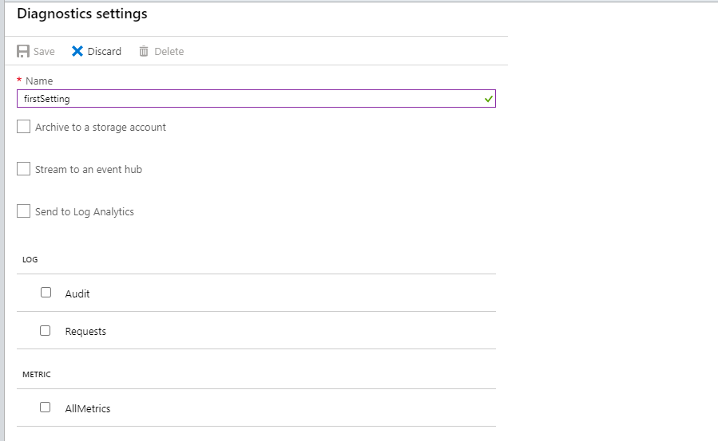

# Question123 Implement non-relational data stores - D

Your team is developing an application with Azure Cosmos DB as the data solution. The application will use the MongoDB API for a document-based database to store items.   
  
You need to provision Cosmos DB with the correct container and item types.   
  
Which container and item types should you use? Each correct answer presents part of the solution.

Drag and drop the answers

https://pts.measureup.com/web/instances/MUP/assets/images/DP-200/DP-200_65235/gsDP-200_003d.gif

https://pts.measureup.com/web/instances/MUP/assets/images/DP-200/DP-200_65235/gsDP-200_003b.gif

https://pts.measureup.com/web/instances/MUP/assets/images/DP-200/DP-200_65235/gsDP-200_003d.gif

https://pts.measureup.com/web/instances/MUP/assets/images/DP-200/DP-200_65235/gsDP-200_003b.gif

https://pts.measureup.com/web/instances/MUP/assets/images/DP-200/DP-200_65235/gsDP-200_003e.gif

https://pts.measureup.com/web/instances/MUP/assets/images/DP-200/DP-200_65235/gsDP-200_003c.gif

https://pts.measureup.com/web/instances/MUP/assets/images/DP-200/DP-200_65235/gsDP-200_003a.gif

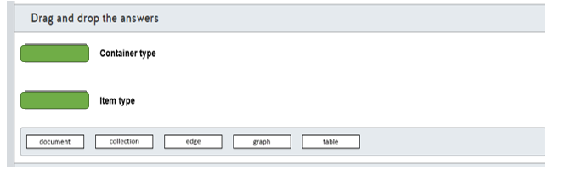

# Question124 Monitor data storage-

You manage an Azure SQL Data Warehouse Gen2 with caching enabled.  
  
Business users report slow performance while running reports. You try to troubleshoot the issue and discover that your working data set does not fit completely into the cache. You solve the issue by scaling up your data warehouse.  
  
You need to implement a monitoring alert that anticipates this situation using Cache hit percentage and Cache used percentage metrics.  
  
How should you configure these metrics? To answer, select the appropriate options from the drop-down menus.

Choose the correct options

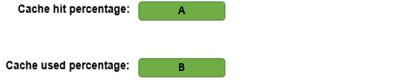

A)

1. High
2. Low

B)

1. High
2. Low

# Question125 Monitor data storage - D

Your company is responsible for a globally-distributed application to support foreign trade operators. This application uses Cosmos DB as the main database, with throughput provisioned on a container level.   
  
Customers are grouped in different tables based on which trade rules they work with. Customers that use a particular trade rule report errors using the application.  
  
You discover that this issue was caused by under-provisioned Requests Units (RU) in this specific trade rule table.  
  
You need to implement an alert using a metric that best anticipates these issues.  
  
Which metric should you use to implement this alert?

Choose the correct answer

Provisioned throughput by container

Total Request Units by container

Request Count by HTTP status code

Max consumed RU per second by partition

# Question126 Monitor data storage-

You implement Azure SQL Database to store sensitive data for your company. Only users from a specified region can access this database.   
  
Because of a compliance requirement, you need to detect unusual access by monitoring access patterns from the database.  
  
You need to configure the Azure SQL Database server to email the compliance department when a potential risk access occurs.  
  
Which three actions should you perform in sequence? To answer, move the appropriate actions from the list of actions to the answer area and arrange them in the correct order.

Create a list in the correct order

Possible actions

Actions in order

* Add a server-level firewall rule.
* Set the Advanced Threat Protection type only for anomalous client login.
* Enable auditing.
* Enable Advanced Data Security.
* Configure the feature to send email alerts to compliance.
* Set the Advanced Threat Protection type only for unsafe action.

# Question127 Monitor data storage-

You work as a Data Engineer for an image processing company.   
  
Users upload files to be analyzed by Azure HDInsight in an Azure Storage Account named Uploads. Files are stored in a blob storage container.  
  
You need to create a report that shows how much data was uploaded in each time frame.  
  
You create a new chart in Azure monitor for this report.  
  
How should you configure this chart? To answer, select the appropriate options from the drop-down menus.

Choose the correct options

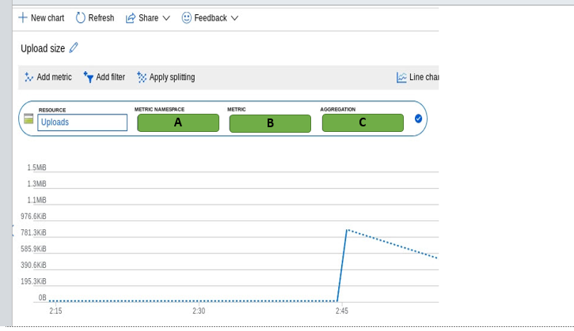

A)

Account

Blob

File

B)

1. Capacity
2. Ingress
3. Transaction

C)

1. Max
2. Min
3. Sum

# Question128 Monitor data storage - D

Your company offers a Software-as-a-Service (SaaS) application for a support ticket system.  
  
Each customer of the application runs in a multi-tenant, isolated database hosted on Azure SQL Elastic Pool Database and uses a Database Transaction Unit (DTU) based provisioning model.  
  
The Sales team starts a campaign to attract more customers, so increasing DTU capacity could be necessary.  
  
You need to monitor this database based on a metric that best anticipates out-of-capacity and performance issues. You also need to minimize the administrative effort to manage this alert.  
  
Which metric should you implement in the monitoring alert?

Choose the correct answer

CPU percentage

DTU percentage

Data IO percentage

eDTU used

# Question129 Monitor data storage-

You manage multiple Azure SQL Databases for an insurance company. These databases are provisioned in a tier of a vCore-based purchasing model.  
  
Th Security team needs to audit all databases and correlate audit logs with logs generated by other Azure services. This analysis should be used to send alerts when suspicious operations occur.  
  
You need to implement auditing in these databases to meet the security requirements while minimizing implementation efforts.  
  
Which two actions should you perform to implement auditing? Each correct answer presents part of the solution.

Choose the correct answers

Configure Azure Event Hub as the audit log destination.

Configure Azure Blob Storage as the audit log destination.

Enable auditing at the database level.

Configure Azure Log Analytics as the audit log destination.

Enable auditing at the server level.

# Question130 Monitor data storage-

You manage a big data solution for a pharmaceutical group. Stores scan customer prescriptions into image files. Each prescription scan is usually 1 MB. The files are stored in Azure Data Lake Storage Gen 2.  
  
The solution uses an HDInsight cluster to analyze the prescriptions in Data Lake Storage. After data is processed, files are moved to the cool tier in Data Lake Storage.  
  
On some occasions, stores upload prescription scans with a higher resolution, resulting in a file size greater than 20 MB. This causes performance degradation in the HDInsight analysis process.  
  
You need to monitor when files uploaded to Data Lake Storage are larger than 20 MB to anticipate HDInsight performance degradation.  
  
Which metric and dimension should you use? To answer, select the appropriate options from the drop-down menus.

Choose the correct options

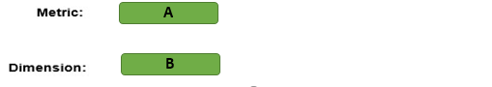

A)

1. Blob Capacity Average
2. File Capacity Average
3. Used Capacity Average

B)

1. Blob Tier
2. Blob Type
3. Response Type

# Question131 Monitor data storage-

You are developing a monitoring solution for an Azure Synapse Analytics SQL pool.  
  
The monitoring solution has the following requirements:

* Query executions must be logged.
* Waits (including queues and blocking waits) must be logged.
* Kusto queries must be used to analyze the logged data.

You create a Log Analytics workspace.  
  
You need to implement the monitoring solution.  
  
Which four actions should you perform in sequence? To answer, move the appropriate actions from the list of actions to the answer area and arrange them in the correct order.

Create a list in the correct order

Actions

Actions in order

* Write Kusto queries using the dm_pdw_sql_requests and dm_pdw_waits tables.
* Enable capturing metrics.
* Write Kusto queries using the AzureMetrics table.
* Enable auditing on the Synapse SQL pool (data warehouse) pane.
* Add a diagnostic setting in the Synapse SQL pool (data warehouse) pane.
* Select Send to Log Analytics.
* Select the ExecRequests and Waits log options.
* Write Kusto queries using the AzureDiagnostics table.

# Question132 Monitor data storage-

You have an Azure Synapse Analytics SQL pool.  
  
You are implementing a data loading process using Polybase. The data must be loaded from Data Lake Storage Gen2. The data is stored in a directory as text files.  
  
One of the external tables has this definition:

CREATE EXTERNAL TABLE [ext].[fact_Order] (

[Order Key] [bigint] NOT NULL,

[City Key] [int] NOT NULL,

[Customer Key] [int] NOT NULL,

[Stock Item Key] [int] NOT NULL,

[Order Date Key] [date] NOT NULL,

[Picked Date Key] [date] NULL,

[Salesperson Key] [int] NOT NULL,

[Picker Key] [int] NULL,

[WWI Order ID] [int] NOT NULL,

[WWI Backorder ID] [int] NULL,

[Description] [nvarchar](100) NOT NULL,

[Package] [nvarchar](50) NOT NULL,

[Quantity] [int] NOT NULL,

[Unit Price] [decimal](18, 2) NOT NULL,

[Tax Rate] [decimal](18, 3) NOT NULL,

[Total Excluding Tax] [decimal](18, 2) NOT NULL,

[Tax Amount] [decimal](18, 2) NOT NULL,

[Total Including Tax] [decimal](18, 2) NOT NULL,

[Lineage Key] [int] NOT NULL

)

WITH ( LOCATION ='/fact_Order/',

DATA_SOURCE = WWIStorage,

FILE_FORMAT = TextFileFormat,

REJECT_TYPE = VALUE,

REJECT_VALUE = 10

);  
  
You receive this error when querying the external table in SSMS:

Rows were rejected while reading from external source(s).

11 rows rejected from external table [fact_Order] in plan step 2 of query execution:

Location: '/fact_Order/fact_Order.csv' Column ordinal: 15, Expected data type: DECIMAL(18,2).

Location: '/fact_Order/fact_Order.csv' Column ordinal: 15, Expected data type: DECIMAL(18,2).

Location: '/fact_Order/fact_Order.csv' Column ordinal: 15, Expected data type: DECIMAL(18,2).

Location: '/fact_Order/fact_Order.csv' Column ordinal: 15, Expected data type: DECIMAL(18,2).

Location: '/fact_Order/fact_Order.csv' Column ordinal: 15, Expected data type: DECIMAL(18,2).

Location: '/fact_Order/fact_Order.csv' Column ordinal: 15, Expected data type: DECIMAL(18,2).

Location: '/fact_Order/fact_Order.csv' Column ordinal: 15, Expected data type: DECIMAL(18,2).

Location: '/fact_Order/fact_Order.csv' Column ordinal: 15, Expected data type: DECIMAL(18,2).

Location: '/fact_Order/fact_Order.csv' Column ordinal: 15, Expected data type: DECIMAL(18,2).

Location: '/fact_Order/fact_Order.csv' Column ordinal: 15, Expected data type: DECIMAL(18,2).

and 1 more...

Msg 107090, Level 16, State 1, Line 1

107090;Query aborted-- the maximum reject threshold (10 rows) was reached while reading from an external source: 11 rows rejected out of total 11 rows processed.

For each of the following statements, select Yes if the statement is true. Otherwise, select No.

|  |  |  |
| --- | --- | --- |
| **Statement** | **Yes** | **No** |
| The data to import contains more than 10 rows that do not conform to the specified external file format (dirty records). |  |  |
| You can use the sys.dm_pdw_errors Dynamic Management View to monitor for this error. |  |  |
| Failed rows will be written to a subdirectory named '_rejectedrows' in the Azure storage account. |  |  |

# Question133 Monitor data processing-

You deploy Azure Databricks for your organization in the Microsoft Azure cloud to support development of a new big data analytics solution.  
  
You already use Azure Monitor to monitor the performance of other corporate solutions.  
  
You need to enable visualization of Azure Databricks metrics in Azure Monitor as well.  
  
Which options describe the way you can enable your strategy? To answer, select the appropriate options from the drop-down menus.

Choose the correct options

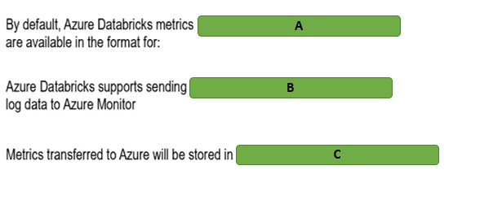

A)

1. Ganglia
2. Azure Monitor
3. Datadog

B)

1. Natively
2. Using a third-party library
3. Using the open neural network exchange (ONNX) runtime

C)

1. Azure Log Analytics workspace
2. Azure Network Watcher
3. Client’s own DB instance

# Question134 Monitor data processing-

You are managing several HDInsight clusters in your company’s Azure subscription. Your line manager asks you to enable specific monitoring tasks for HDInsight clusters.  
  
You need to choose a relevant tool for each task.  
  
Which tool should you use? To answer, select the appropriate options from the drop-down menus.

Choose the correct options

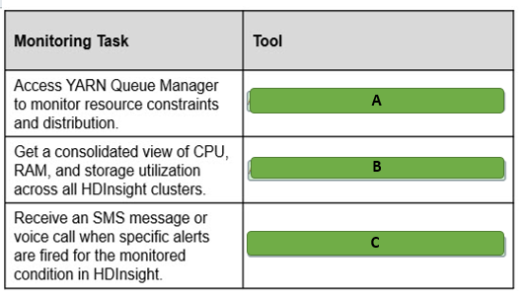

A)

Apache Ambari

Azure Monitor logs

Windows Event Viewer

Linux dmesg

B)

Apache Ambari

Azure Monitor logs

Windows Event Viewer

Linux dmesg

C)

Apache Ambari

Azure Monitor

Windows Event Viewer

Linux dmesg

# Question135 Monitor data processing-

You manage an Azure SQL Database instance that uses the Database Throughput Unit (DTU) pricing model. It has a maximum of 5 DTUs and is two gigabytes (GB) in size. You must upgrade the instance's tier if its CPU reaches 50 percent, its memory usage reaches one GB, or if its disk reads or writes per second reach 50 percent of its capacity.  
  
You need to create an alert that monitors the instance over a 12-hour period.  
  
How should you configure the alert? To answer, select the appropriate configuration values from the drop-down menus.

Choose the correct options

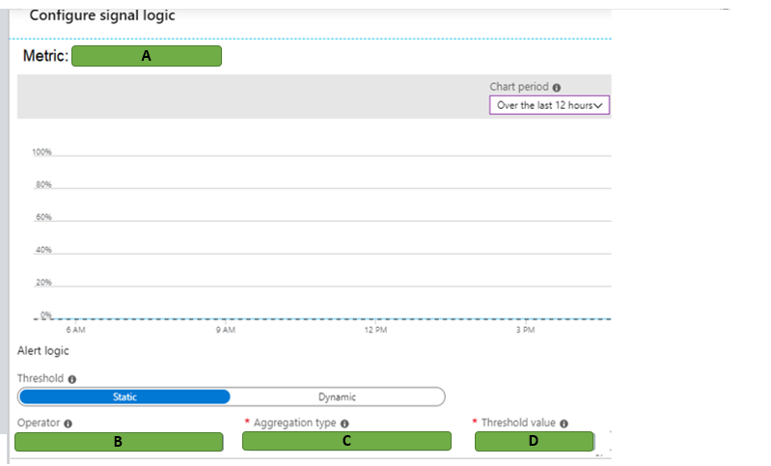

A)

1. Data space used
2. DTU Percentage

B)

1. Greater than or equal to
2. Less than

C)

1. Average
2. Minimum
3. Maximum

D)

1. 2.5
2. 50

# Question136 Monitor data processing-

You have an Azure SQL Database instance with a single database. You are enabling diagnostics logging. You want to gather information about performance recommendations, queries that are taking the longest to run, and CPU and Database Throughput Unit (DTU) limits and percentages.  
  
You need to determine which three logs to enable.  
  
Which three logs should you enable? To answer, move the appropriate logs from the list of possible logs to the answer area and arrange them in any order.

Create a list in any order

Possible logs

Logs to monitor

* DatabaseWaitStatistics
* QueryStoreWaitStatistics
* Basic metrics
* QueryStoreRuntimeStatistics
* SQLInsights

# Question137 Monitor data processing-

You are a data engineer for your company. You have an HDInsight cluster in Azure.  
  
You need to monitor the cluster for performance.  
  
What should you do?

Choose the correct answer

Create a Log Analytics workspace and use Azure Advisor.

Create a Data Lake Analytics account and use Azure Advisor.

Create a Data Lake Analytics account and use Azure Monitor.

Create a Log Analytics workspace and use Azure Monitor.

# Question138 Monitor data processing-

You are a data engineer for your company. You have an Azure Databricks account. You want to use Azure Monitor to monitor the Databricks account.  
  
You need to choose a solution for sending application metrics to Azure Monitor.  
  
Which library or tool should you use?

Choose the correct answer

Log4j

Dropwizard

Azure CLI

Powershell

# Question139 Monitor data processing-

You are a data engineer. You want to set up an alert to monitor a Stream Analytics job. You want to receive an alert when the job stops unexpectedly.  
  
You need to configure the alert.  
  
How should you configure the alert? To answer, select the appropriate configurations from the drop-down menus.

Choose the correct options

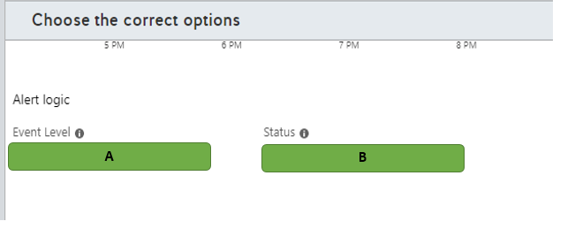

A)

1. All
2. Warning

B)

1. Failed
2. Succeeded

# Question140 Monitor data processing-

You are a data engineer. You manage an HDInsight cluster. You want to monitor the cluster's performance by using a web user interface.  
  
You need to choose the appropriate tool for monitoring.  
  
Which tool should you use?

Choose the correct answer

Azure Stream Analytics

Azure Log Analytics

Apache Ambari

Apache Spark

# Question141 Monitor data processing - D

You are a data engineer. You have an Azure Data Factory pipeline in the US East region. You realize that pipeline run-data is deleted after 45 days.  
  
You need to keep the run-data from the pipeline for longer than 45 days.  
  
What should you do?

Choose the correct answer

Configure diagnostics logs to send data to a blob storage account.

Re-create the Data Factory pipeline in the US East 2 region.

Add a lock with the CanNotDelete lock type.

Re-create the Data Factory pipeline and enable Git.

# Question142 Monitor data processing-

You manage an Azure SQL Data Warehouse. You have two tables named DimEmployee and FactWorkResults.  
  
You need to determine the top 10 longest running queries across both tables.  
  
How should you write the SQL statement? To answer, select the appropriate code segments from the drop-down menus.

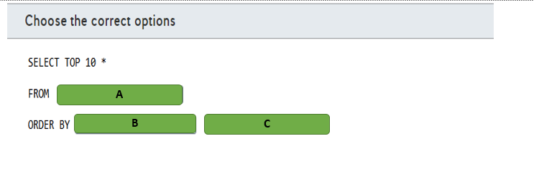

A)

1. Sys.dm_pdw_exec_requests
2. DimEmployee, FactWorkResults

B)

1. Submit_time
2. Total_elapsed_time

C)

1. ASC
2. DESC

# Question143 Monitor data processing-

Your company has an Azure HDInsight solution that uses an Apache Hadoop cluster to process and analyze data.  
  
Your management reports slowdowns during a specific time window.  
  
You need to provide a monitoring solution that tracks cluster performance issues and alerts your team as soon as possible.  
  
Which two monitoring solutions should you use? Each correct answer presents a complete solution.

Choose the correct answers

Azure Monitor metrics

Azure Monitor Log Analytics

Apache Ambari

HDInsight Cluster REST API

# Question144 Monitor data processing - D

You manage an Azure Stream Analytics job for a real-time log streaming solution.  
  
The logs are consumed by PowerBI to generate a dashboard. Users of this dashboard report that new data is not being streamed to PowerBI.  
  
You troubleshoot this issue and discover that the Stream Analytics job stopped unexpectedly.  
  
You need to configure an alert to monitor this issue.  
  
Which metric or activity log should you implement for this alert?

Choose the correct answer

Streaming Units (SU) percentage utilization

Runtime Errors

All Administrative operations

Output Events

# Question145 Monitor data processing-

Your company uses an Azure Stream Analytics job for a streaming solution. The job resource in Azure Portal is named FraudAnalysis.  
  
Other services in this solution send diagnostic logs to an Azure Monitor Log Analytics workspace. This Log Analytics workspace resource is named LogWorkspace.  
  
Both the Log Analytics and the Stream Analytics job are provisioned in a resource group named Production.  
  
You need to complete the PowerShell command to integrate the job diagnostic logs with Azure Monitor to correlate log data with other services.  
  
How should you complete the PowerShell command? To answer, select the appropriate options from the drop-down menus.

Choose the correct options

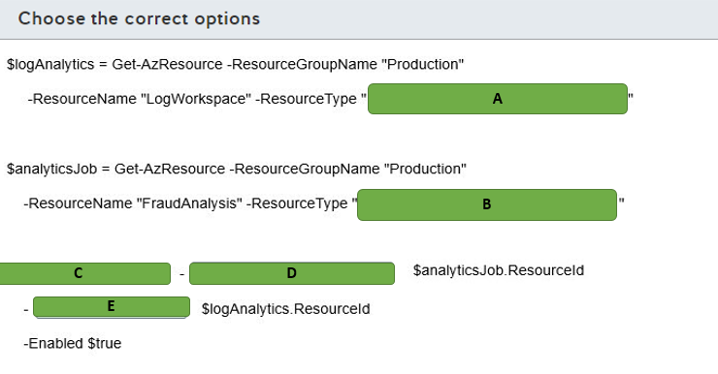

A)

1. Microsoft.Insights/diagnosticSettings
2. Microsoft.OperationalInsights/workspaces
3. Microsoft.StreamAnalytics/streamingjobs

B)

1. Microsoft.Insights/diagnosticSettings
2. Microsoft.OperationalInsights/workspaces
3. Microsoft.StreamAnalytics/streamingjobs

C)

1. Add-AzLogProfile
2. Enable-AzActivityLogAlert
3. Set-AzDiagnosticSetting

D)

1. ResourceId
2. StorageAccountIdWorkspaceId

E)

1. ResourceId
2. StorageAccountId
3. WorkspaceId

# Question146 Monitor data processing - D

Your team manages a data pipeline in Azure Data Factory.  
  
This pipeline is executed every week on Sunday and moves data to an Azure SQL Data Warehouse that is used by the whole company.  
  
You have the following monitoring requirements for this data pipeline:

* If a pipeline run fails, your team needs to be notified so it can remediate the problem.
* Pipeline run metrics from the last 90 days must be stored for analytics and historical data.

You need to implement a monitoring solution to satisfy these requirements with minimal implementation efforts.  
  
Which solution should you use?

Choose the correct answer

Azure Data Factory Monitor

Azure Data Factory REST API

Azure Monitor

.NET Software Development Kit (SDK)

# Question147 Monitor data processing-

You manage an Azure Stream Analytics job to analyze banking system transactions for fraud detection.  
  
You recently optimized the Streaming Unit (SU) consumption for the job by implementing query parallelization. Banking system transactions are expected to increase radically during an upcoming big sales event.  
You need to create an alert if SU consumption is higher than 80 percent.  
  
How should you configure the alert? To answer, select the appropriate options from the drop-down menus.

Choose the correct options

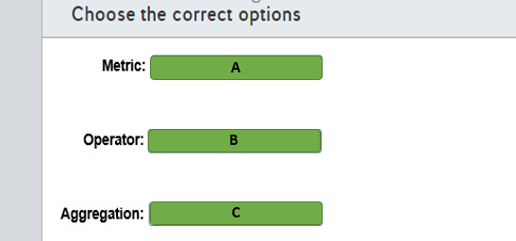

A)

1. Input events
2. Runtime error
3. SU % utilization

B)

1. Greater than
2. Less than
3. Less than or equal to

C)

1. Average
2. Maximum
3. Minimum

# Question148 Monitor data processing - D

You create an Azure Data Factory pipeline. You also create a Log Analytics workspace. In Azure Monitor you set the diagnostic settings as shown in the exhibit.  
  
Which tables can you query using KQL in the Log Analytics workspace?

Choose the correct answer

PipelineRuns and ActivityRuns

ADFPipelineRun and AzureMetrics

ADFPipelineRun and PipelineSucceededRuns

AzureDiagnostics and ActivityRuns

ADFPipelineRun, ADFTriggerRun, and ADFActivityRun

# Question149 Monitor data processing-

You create an Azure Data Factory pipeline. You have a Log Analytics workspace.  
  
In Azure Monitor you set the diagnostic settings for the Data Factory as shown in the exhibit.  
  
You need to create a log alert in the Azure portal using Azure Monitor with a KQL query. The query should be executed every 20 minutes and have a time window of 20 minutes.  
  
How should you configure the settings for the alert in Azure Monitor? To answer, drag the appropriate value to each setting. Each value may be used once, more than once, or not at all.

Drag and drop the answers

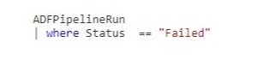

https://pts.measureup.com/web/instances/MUP/assets/images/DP-200/DP-200_71609/fake_5e519808427fe.png

https://pts.measureup.com/web/instances/MUP/assets/images/DP-200/DP-200_71609/fake_5e519808427fe.png



https://pts.measureup.com/web/instances/MUP/assets/images/DP-200/DP-200_71609/fake_5e519808427fe.png

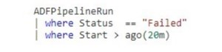

https://pts.measureup.com/web/instances/MUP/assets/images/DP-200/DP-200_71609/fake_5e5198195f630.png

https://pts.measureup.com/web/instances/MUP/assets/images/DP-200/DP-200_71609/fake_5e519823e4372.png

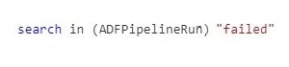

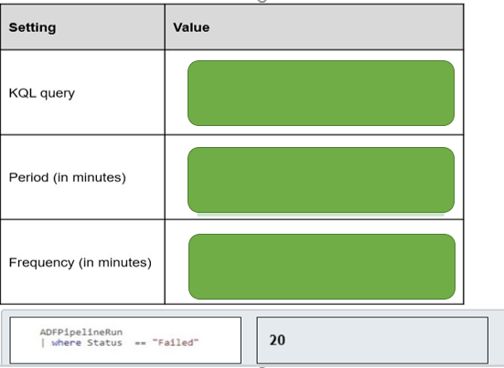

# Question150 Implement non-relational data stores - D

You are a data engineer for a practice test provider. You plan to use an Azure Cosmos DB to store exam content. You must be able to retrieve exam content by using a query similar to the following:  
  
SELECT * FROM Exams e WHERE e.number = "DP-200"  
  
You need to generate the Cosmos DB account and database.  
  
How should you complete the Azure CLI commands? To answer, select the appropriate options from the drop-down menus.

Choose the correct options

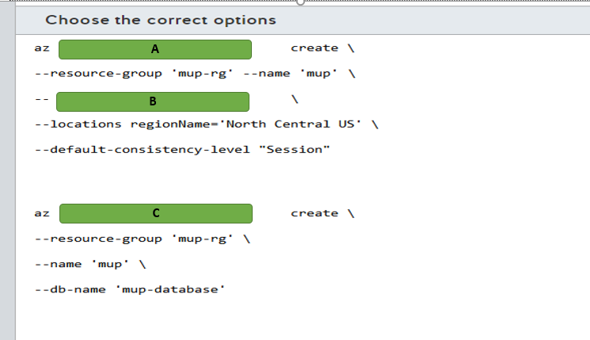

A)

1. Cosmodb
2. Cosmodb collection
3. Cosmodb database

B)

1. Capabilities EnableCassandra
2. Capabilities EnableGremlin
3. Capabilities EnablesTable
4. Kind GlobalDocumentDB
5. Kind MongoDB

C)

1. Cosmodb
2. Cosmodb collection
3. Cosmodb database

# Question151 Monitor data processing-

You have an Azure resource group named resourcegroup1. This resource group contains the following resources:

* sqlserver1 of type (logical Azure) SQL server
* synapsesqlpool1 of type Synapse SQL pool (data warehouse)

You need to use the Azure portal to set up an alert rule when 80 percent of the maximum resource capacity is used.  
  
How should you configure the alert rule in Azure Monitor? To answer, drag the appropriate value to each alert rule setting. A value may be used once, more than once, or not at all.

Drag and drop the answers

https://pts.measureup.com/web/instances/MUP/assets/images/DP-200/DP-200_72449/fake_5e6273132de2d.png

https://pts.measureup.com/web/instances/MUP/assets/images/DP-200/DP-200_72449/fake_5e6274046905a.png

https://pts.measureup.com/web/instances/MUP/assets/images/DP-200/DP-200_72449/fake_5e627428c8eb1.png

https://pts.measureup.com/web/instances/MUP/assets/images/DP-200/DP-200_72449/fake_5e6273132de2d.png

https://pts.measureup.com/web/instances/MUP/assets/images/DP-200/DP-200_72449/fake_5e6274046905a.png

https://pts.measureup.com/web/instances/MUP/assets/images/DP-200/DP-200_72449/fake_5e627428c8eb1.png

https://pts.measureup.com/web/instances/MUP/assets/images/DP-200/DP-200_72449/fake_5e627327f2c95.png

https://pts.measureup.com/web/instances/MUP/assets/images/DP-200/DP-200_72449/fake_5e62740c2c74d.png

https://pts.measureup.com/web/instances/MUP/assets/images/DP-200/DP-200_72449/fake_5e62743186c51.png

https://pts.measureup.com/web/instances/MUP/assets/images/DP-200/DP-200_72449/fake_5e62743d54ed6.png

https://pts.measureup.com/web/instances/MUP/assets/images/DP-200/DP-200_72449/fake_5e6504830d0e4.png

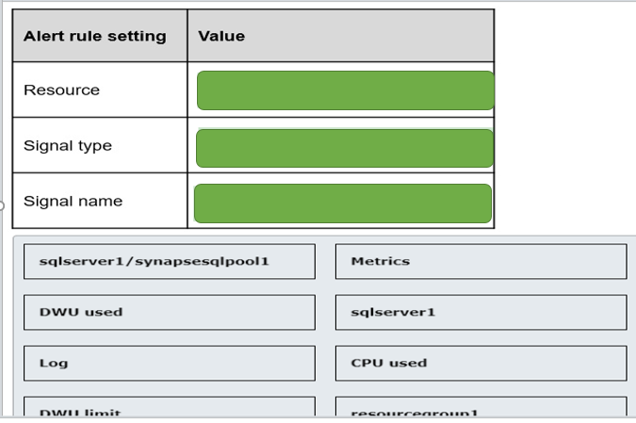

# Question152 Monitor data processing-

You have an Azure SQL Database. Auditing is enabled, using a Log Analytics workspace as a destination.  
  
You need to write a Kusto query giving an overview of the failed login attempts of the last week. The result of the query must show one row per IP address (of the client) and the number of failed logins attempts per IP address.  
  
How should you configure the query? To answer, select the appropriate options from the drop-down menus.

Choose the correct options

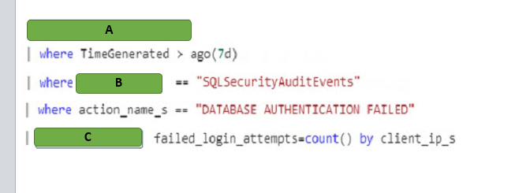

A)

1. AzureDiagnostics
2. SacurityEvent
3. Event

B)

1. Summarise
2. Select
3. project

C)

1. Category
2. $table
3. Event

# Question153 Optimize Azure data solutions-

Your company’s quality control system uses a single container in Azure Cosmos DB to store information about quality checks (successful checks and defect detection) of finished products.  
  
Review of the data shows little value in storing successful check records long term. Management asks you to enable a data retention policy in Azure Cosmos DB, so that successful check records are automatically deleted after one hour, while defect detection records are retained indefinitely.  
  
You need to update Time-to-Live (TTL) settings in Azure Cosmos DB to enable the requested data retention policy.  
  
How should you configure TTL settings? To answer, select the appropriate options from the drop-down menus.

Choose the correct options

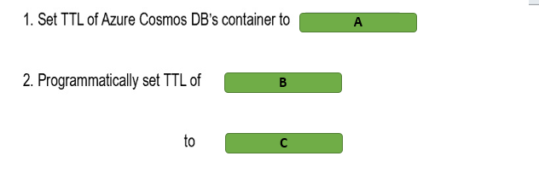

A)

1. 3600
2. -1

B)

1. Defect detection record
2. Successful check records

C)

1. -1
2. null

# Question154 Optimize Azure data solutions-

You are configuring a star-schema model in Azure SQL Data Warehouse for a new Operations Analytics solution.  
  
Telemetry data from factories will be loaded into the fact table, and grow by about 5 GB every month. Product details, which change infrequently, will be loaded into dimension tables, with the total size of about 50 MB.  
  
Daily shipment updates from an external website are to be fast loaded into the temporary staging table first, before being processed and then moved into the fact table.  
  
You need to choose the right data distribution method for the fact, dimension, and staging tables to optimize future data query operations.  
  
Which methods should you use? To answer, drag the appropriate data distribution method to each table type. A distribution method may be used once, more than once, or not at all.

Drag and drop the answers

https://pts.measureup.com/web/instances/MUP/assets/images/DP-200/DP-200_63827/ltMS_DP-200_SelectPlace_3(6).jpeg

https://pts.measureup.com/web/instances/MUP/assets/images/DP-200/DP-200_63827/ltMS_DP-200_SelectPlace_3(7).jpeg

https://pts.measureup.com/web/instances/MUP/assets/images/DP-200/DP-200_63827/ltMS_DP-200_SelectPlace_3(9).jpeg

https://pts.measureup.com/web/instances/MUP/assets/images/DP-200/DP-200_63827/ltMS_DP-200_SelectPlace_3(6).jpeg

https://pts.measureup.com/web/instances/MUP/assets/images/DP-200/DP-200_63827/ltMS_DP-200_SelectPlace_3(7).jpeg

https://pts.measureup.com/web/instances/MUP/assets/images/DP-200/DP-200_63827/ltMS_DP-200_SelectPlace_3(9).jpeg

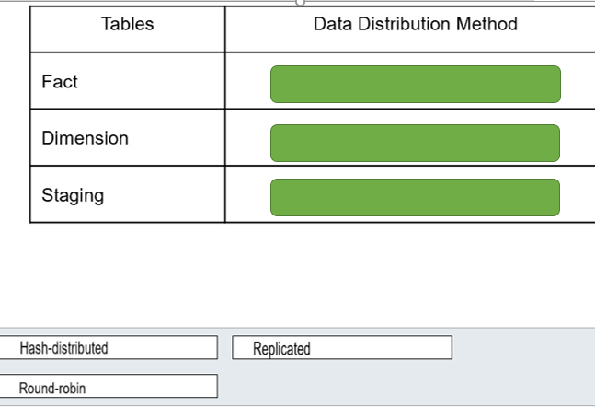

# Question155 Optimize Azure data solutions - D

Your company’s quality control system uses Azure Cosmos DB to store information about quality checks (successful checks and defect detection) of finished products.  
  
Management asks you to enable a data retention policy in Azure Cosmos DB, so that successful check entries are automatically deleted after one hour, while defect detection records are retained indefinitely.  
  
You need to update the Time-To-Live (TTL) settings in Azure Cosmos DB to enable this data retention policy.  
  
What should you do?

Choose the correct answer

Set the TTL settings of the Azure Cosmos DB container to -1, and programmatically set the TTL of defect detection items to null.

Set the TTL settings of the Azure Cosmos DB container to -1, and programmatically set the TTL of successful check items to null.

Set the TTL settings of the Azure Cosmos DB container to 3600, and programmatically set the TTL of defect detection items to -1.

Set the TTL settings of the Azure Cosmos DB container to 3600, and programmatically set the TTL of successful check items to -1.

# Question156 Optimize Azure data solutions - D

You manage an Azure SQL Database service that uses a single database. A particular query is taking a long time to run.  
  
You need to determine what about the query is causing it to take so long.  
  
What should you do?

Choose the correct answer

Run SQL Profiler.

Display the actual execution plan.

Drop all clustered indexes.

Display the estimated execution plan.

# Question157 Optimize Azure data solutions – Not complete question

You manage an Azure SQL Database. You run the query and display the execution plan shown in the exhibit. There are 10 rows in the Department table.  
  
You need to determine whether you can improve the performance of the query.  
  
What should you conclude?

Choose the correct answer

You need to remove the clustered index from the Department table.

Performance is optimal.

You need to add a non-clustered index on the Name column of the Department table.

You need to remove the clustered index from the Employee table.

# Question158 Optimize Azure data solutions-

You manage an Azure SQL Data Warehouse. You have three tables:  
  
DimProduct: Small table that changes infrequently  
DimCustomer: Small table that changes infrequently  
FactSales: Large table that changes frequently  
  
All three tables use round-robin distribution. Queries join all three tables.   
  
You need to optimize these tables for performance.  
  
For each of the following statements, select Yes if the statement is true. Otherwise, select No.

|  |  |  |
| --- | --- | --- |
| **Statement** | **Yes** | **No** |
| You should use a replicated table for DimProduct. |  |  |
| You should use a replicated table for DimCustomer. |  |  |
| You should use a replicated table for FactSales. |  |  |

# Question159 Optimize Azure data solutions-

You manage an Azure SQL Data Warehouse. You have three tables:  
  
DimExam: 2000 rows, 200 megabytes (MB), changes infrequently  
DimCandidate: 400 rows, 40 MB, changes infrequently  
FactScores: 100,000,000 rows, 500 gigabytes (GB), changes frequently  
  
All three tables use round-robin distribution. Queries join all three tables.   
  
You need to optimize these tables for performance.  
  
For each of the following statements, select Yes if the statement is true. Otherwise, select No.

|  |  |  |
| --- | --- | --- |
| **Statement** | **Yes** | **No** |
| You should use hash distribution for DimExam. |  |  |
| You should use hash distribution for DimCandidate. |  |  |
| You should use hash distribution for FactScores. |  |  |

# Question160 Optimize Azure data solutions-

You manage an Azure SQL Data Warehouse. You have four tables:  
  
DimProduct: 2000 rows, 200 megabytes (MB), changes infrequently  
DimCustomer: 400 rows, 40 megabytes (MB), changes infrequently  
FactSales: 100,000,000 rows, 500 gigabytes (GB), changes frequently  
FactOrders: 100,000,000 rows, 500 gigabytes (GB), changes frequently  
  
All three tables use hash distribution. Queries join the DimProduct, DimCustomer, and FactSales tables. The FactOrders table contains all the data it needs.   
  
You need to optimize these tables for performance.  
  
For each of the following statements, select Yes if the statement is true. Otherwise, select No.

|  |  |  |
| --- | --- | --- |
| **Statement** | **Yes** | **No** |
| You should use a replicated table for DimProduct. |  |  |
| You should use a replicated table for DimCustomer. |  |  |
| You should use a replicated table for FactSales. |  |  |
| You should use round-robin distribution for FactOrders. |  |  |

# Question161 Optimize Azure data solutions-

You manage an Azure Streaming Analytics job.  
  
You need to administer the job so that it uses optimal performance.  
  
For each of the following statements, select Yes if the statement is true. Otherwise, select No.

|  |  |  |
| --- | --- | --- |
| **Statement** | **Yes** | **No** |
| You should start with two Streaming Units (SUs) for queries that do not use PARTITION BY. |  |  |
| You should keep the Streaming Unit (SU) metric below 80 percent. |  |  |
| You should allocate more SUs than you need. |  |  |

# Question162 Optimize Azure data solutions - D

You manage an Azure Data Lake Storage Gen2 account. Your source data is stored on file servers and SQL Server on-premises. You anticipate that it will take a long time to copy the data from your company to Data Lake over the public internet.  
  
You need to ensure optimal performance when copying the source data to Azure.  
  
What should you do?

Choose the correct answer

Create an Azure Data Lake Analytics account.

Create an Azure Data Factory account.

Install Active Directory (AD) Connect on-premises.

Use ExpressRoute.

# Question163 Optimize Azure data solutions-

You are a data engineer for your company. You have several blob storage accounts that you need to manage.  
  
You need to match the access tier with the blob usage.  
  
Which access tier should you use for each scenario? To answer, drag the appropriate access tier to each blob usage. An access tier may be used once, more than once, or not at all.

Drag and drop the answers

https://pts.measureup.com/web/instances/MUP/assets/images/DP-200/DP-200_64227/Archive.png

https://pts.measureup.com/web/instances/MUP/assets/images/DP-200/DP-200_64227/Cool.png

https://pts.measureup.com/web/instances/MUP/assets/images/DP-200/DP-200_64227/Hot.png

https://pts.measureup.com/web/instances/MUP/assets/images/DP-200/DP-200_64227/Archive.png

https://pts.measureup.com/web/instances/MUP/assets/images/DP-200/DP-200_64227/Cool.png

https://pts.measureup.com/web/instances/MUP/assets/images/DP-200/DP-200_64227/Hot.png

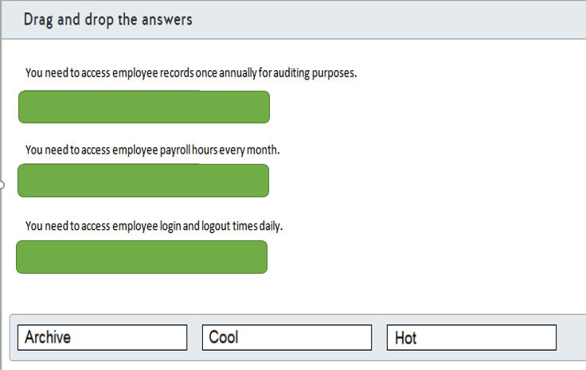

# Question164 Optimize Azure data solutions-

Your company has an application for technical writers to share, review and publish exam questions. The application allows live reviews for questions and provides reports about question performance after the questions are published. All questions and reviews and stored in Azure SQL Database.   
  
Writers are able to report question metrics in an exam results table with millions of rows. Reports include the percentage of correct answers, average question rating and answer count per question.  
  
After a question is published, live reviews are disabled and previous reviews are archived in a separate database.  
  
Writers report the following performance issues with the application:

* Some delays are occurring during the live reviews.
* Reports are taking too long to be generated.

You need to resolve the performance issues.  
  
Which two features should you use? Each correct answer presents a complete solution.

Choose the correct answers

Heap table

Memory-optimized table

Nonclustered index

Columnstore index

Partitioned view

# Question165 Optimize Azure data solutions-

Your company manages an ecommerce platform for a large retailer. The platform is composed of thousands of web servers running on Azure virtual machines (VMs). The platform generates approximately three gigabytes (GB) of log data in a day.  
  
The log files for each server are stored in Azure Data Lake Storage Gen2 inside a single folder. This data is processed and analyzed on an HDInsight cluster.  
  
You need to provide some performance improvements while minimizing cost.  
  
Which two changes should you implement? Each correct answer presents a complete solution.

Choose the correct answers

Combine the daily log files into one file.

Use a cool tier for Azure Data Lake Storage Gen2.

Increase the number of worker nodes.

Separate the log files into a daily generated folder.

# Question166 Optimize Azure data solutions-

Your team manages an image recognition process for a security firm. The solution runs on an Azure virtual machine (VM) at a daily frequency.  
  
Images are uploaded to an Azure Blob Storage container. The VM processes the results using the data uploaded from the previous day and stores the results in the same blob storage.  
  
You must meet the following data retention requirements:

* Daily results must be accessible for one week.
* Data for the current month must be available but is rarely used.
* Current year data must be stored for auditing purposes.
* Audit data must be requested at least one day before being accessed.

You need to use a lifecycle policy that minimizes cost.  
  
How should you configure the lifecycle policy? To answer, drag a JSON segment to the most appropriate location. A JSON segment may be used once, more than once, or not at all.

Drag and drop the answers

https://pts.measureup.com/web/instances/MUP/assets/images/DP-200/DP-200_65259/gsDP-200_036a.gif

https://pts.measureup.com/web/instances/MUP/assets/images/DP-200/DP-200_65259/gsDP-200_036b.gif

https://pts.measureup.com/web/instances/MUP/assets/images/DP-200/DP-200_65259/gsDP-200_036d.gif

https://pts.measureup.com/web/instances/MUP/assets/images/DP-200/DP-200_65259/gsDP-200_036f.gif

https://pts.measureup.com/web/instances/MUP/assets/images/DP-200/DP-200_65259/gsDP-200_036g.gif

https://pts.measureup.com/web/instances/MUP/assets/images/DP-200/DP-200_65259/gsDP-200_036a.gif

https://pts.measureup.com/web/instances/MUP/assets/images/DP-200/DP-200_65259/gsDP-200_036b.gif

https://pts.measureup.com/web/instances/MUP/assets/images/DP-200/DP-200_65259/gsDP-200_036d.gif

https://pts.measureup.com/web/instances/MUP/assets/images/DP-200/DP-200_65259/gsDP-200_036f.gif

https://pts.measureup.com/web/instances/MUP/assets/images/DP-200/DP-200_65259/gsDP-200_036g.gif

https://pts.measureup.com/web/instances/MUP/assets/images/DP-200/DP-200_65259/gsDP-200_036c.gif

https://pts.measureup.com/web/instances/MUP/assets/images/DP-200/DP-200_65259/gsDP-200_036e.gif

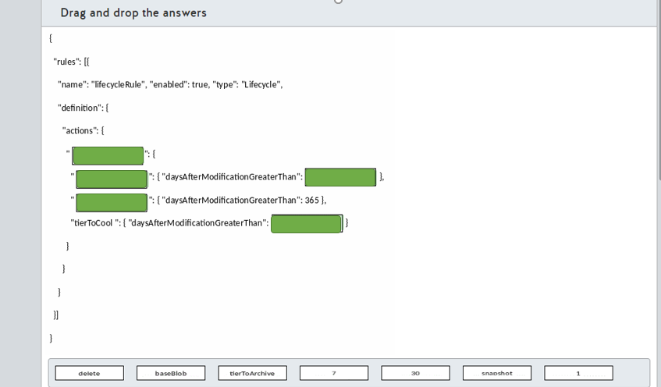

# Question167 Optimize Azure data solutions-

You manage a real-time data analysis solution hosted in Azure.   
  
The solution uses Azure Event Hubs to ingest data and analyze the data in real-time with an Azure Stream Analytics job.  
  
The Stream Analytics job uses 18 Streaming Units (SU). Stream Analytics job metrics and SU percentage utilization metrics have been 90% in average over the last month.  
  
You need to optimize the Azure Stream Analytics job performance.  
  
Which two actions should you perform? Each correct answer presents part of the solution.

Choose the correct answers

Configure event ordering.

Decrease the SU count for the job.

Partition data for query parallelization.

Increase the SU count for the job.

Use Stream Analytics JavaScript user-defined functions.

# Question168 Optimize Azure data solutions-

You need to load data into an Azure Synapse Analytics SQL pool. The data is stored in a general purpose v2 Azure storage account as text files.  
  
You need to use the fastest data loading option.  
  
Which two options can you use to meet your goal? Each correct answer presents a complete solution.

Choose the correct answers

Use SQL Server Integration Services (SSIS).

Use a Copy Activity in Azure Data Factory.

Use the Bulk Copy Program utility (BCP).

Write and run PolyBase T-SQL commands.

Use a Copy Activity in Azure Data Factory with the bulk insert option.

Use the SQL BulkCopy API.

# Question169 Optimize Azure data solutions – Not complete question

You have an Azure Synapse Analytics SQL pool.  
  
The output of the EXPLAIN command is shown in the exhibit.  
  
You need to optimize the performance of a query while minimizing cost.  
  
What should you do?

Choose the correct answer

Update the statistics on the FactInternetSales table.

Upgrade the performance level.

Re-create the FactInternetSales table using hash-distribution on the ProductKey column .

Re-create the FactInternetSales table using round-robin distribution.

Re-create the FactInternetSales table using page compression.